CAPSTONE PROJECT PROPOSAL
Design and Development of a Web-Based Membership Management System: Member Records, Registration, and Fee Tracking

In partial fulfillment for the requirements in Capstone 1 and Research Subject

Botavara, Hynrik P.
Rizol John Mc.
Dordas Rhea Jean.
Galapin, Trixie
Malones, John Ralph.

BUSINESS ANALYTICS MANAGEMENT TRACK

Second Semester 2025-26

ABSTRACT

The study focused on the design and development of a Web-Based Membership Management System: Member Records, Registration, and Fee Tracking to address the challenges encountered in the organization's existing manual membership management processes. Manual procedures for recording member information, processing registrations, monitoring membership fees, recording payments, and preparing reports may result in duplicate records, delayed processing, inaccurate fee monitoring, and difficulties in retrieving and managing organizational information. The proposed system was developed to provide a centralized and computerized platform that improves the efficiency, accuracy, security, and accessibility of membership-related information.

The study employed a developmental research design, which provided a systematic approach to the design, development, implementation, testing, and evaluation of the proposed system. The Agile Software Development Methodology was adopted to support iterative development, continuous testing, user feedback, and progressive improvement of system functionalities. Data gathering techniques, including interviews, observations, and document review, were utilized to identify the organization's existing procedures, problems, and system requirements. The system was designed to provide essential functionalities such as user authentication, member registration, member record management, membership fee tracking, payment recording, and report generation. The system was developed using appropriate web development and database technologies, with MySQL serving as the relational database platform.

The completed system is intended to replace manual membership management procedures with a centralized information system that promotes more organized record management, efficient registration, accurate fee and payment monitoring, and faster report generation. The proposed system also supports improved information security and accessibility for authorized users. Software evaluation based on recognized software quality criteria is intended to determine the system's functional suitability, performance efficiency, compatibility, usability, reliability, security, maintainability, and portability.

Keywords: Web-Based System, Membership Management, Member Records, Member Registration, Membership Fee Tracking, Payment Recording, Database Management

TABLE OF CONTENTS

ABSTRACT ........................................................ 2
CHAPTER 1
INTRODUCTION .................................................... 3
1.1 BACKGROUND OF THE STUDY ...................................... 3
1.2 STATEMENT OF THE PROBLEM ..................................... 5
1.3 OBJECTIVES OF THE STUDY ...................................... 7
1.4 SCOPE AND LIMITATIONS ........................................ 9
1.5 SIGNIFICANCE OF THE STUDY .................................... 10
1.6 DEFINITION OF TERMS .......................................... 13

CHAPTER 2
REVIEW OF RELATED LITERATURE AND STUDIES ........................ 17

2.1 FOREIGN STUDIES ............................................. 18
2.2 LOCAL STUDIES ............................................... 32
2.3 RELATED LITERATURE INFORMATION SYSTEMS ........................ 44
2.4 SYNTHESIS OF THE REVIEWED LITERATURE AND STUDIES .............. 48

CHAPTER 3
METHODOLOGY ...................................................... 50
3.1 RESEARCH DESIGN .............................................. 50
3.2 SYSTEM DEVELOPMENT METHODOLOGY ............................... 52
3.3 SYSTEM ARCHITECTURE ........................................... 67
3.4 TOOLS AND TECHNOLOGIES USED ................................... 69
3.5 DATA GATHERING TECHNIQUES ...................................... 73
3.6 TESTING PROCEDURES ............................................ 75

SUPPORTING DIAGRAMS ............................................... 79

ENTITY RELATIONSHIP DIAGRAM (ERD) .................................. 79
DATA FLOW DIAGRAM (DFD) LEVEL 0 .................................... 82
USE CASE DIAGRAM ................................................... 85
ACTIVITY DIAGRAM ................................................... 89
SEQUENCE DIAGRAM ................................................... 91
DEPLOYMENT DIAGRAM .................................................. 92

CHAPTER 1

INTRODUCTION

1.1 BACKGROUND OF THE STUDY
The rapid advancement of information and communication technology has significantly transformed the way organizations manage their daily operations and organizational records. Traditional paper-based and manual management systems are gradually being replaced by computerized information systems that provide faster, more accurate, and more efficient methods of processing data. These technological innovations have enabled organizations from various sectors, including educational institutions, business establishments, non-government organizations, cooperatives, associations, and community-based organizations, to improve operational efficiency, enhance decision-making, and deliver better services to their members. As organizations continue to grow, the demand for reliable, secure, and accessible information systems has become increasingly important.
Membership-based organizations rely heavily on accurate records to ensure the efficient administration of their operations. These records include personal information of members, registration details, membership status, payment history, and other essential organizational documents. Proper management of these records allows organizations to maintain updated information, monitor membership activities, communicate effectively with members, and generate reports needed for administrative and strategic purposes. However, organizations that continue to utilize manual methods of record keeping often experience difficulties in maintaining accurate and organized records. Paper-based documentation and spreadsheet-based systems are susceptible to data redundancy, misplaced records, delayed retrieval of information, inconsistent updates, and human error, which may negatively affect the overall efficiency of organizational operations.
The registration process is one of the most essential activities within any membership organization. It serves as the initial stage where member information is collected, verified, and stored for future organizational transactions. A well-organized registration system allows administrators to establish accurate member profiles while ensuring that all necessary information is properly documented. Conversely, manual registration procedures require significant time and effort from both administrators and applicants. The repetitive encoding of information, preparation of physical documents, and manual verification of records often result in processing delays, incomplete information, and duplicate member records. As the number of members increases, these challenges become more difficult to manage using conventional methods.
Another significant aspect of membership administration is the monitoring of membership fees. Membership fees provide financial support for organizational activities, projects, maintenance, and administrative operations. Effective monitoring of fee payments enables organizations to determine active and inactive members, identify outstanding balances, generate financial reports, and maintain transparency in financial transactions. However, organizations that rely on manual payment recording frequently encounter problems such as inaccurate computations, missing payment records, delayed updates, and difficulties in preparing financial summaries. These issues may lead to misunderstandings between members and administrators while reducing the overall reliability of financial records.
The implementation of a web-based information system provides an effective solution to these challenges. Unlike standalone desktop applications, web-based systems are accessible through standard web browsers and can be utilized using computers connected to a local network or the Internet, depending on the organization's requirements. This accessibility enables authorized users to manage organizational records from different locations while ensuring that all information is stored within a centralized database. Centralized data management reduces redundancy, improves consistency, and allows multiple authorized users to access updated information simultaneously without compromising data integrity.
Database management systems play a crucial role in ensuring the reliability of computerized information systems. Modern relational database management systems allow organizations to securely store, organize, retrieve, and update large volumes of information with minimal risk of data loss. Through structured database design, organizations can maintain consistent records of members, registrations, payments, and reports while minimizing duplicate entries and maintaining referential integrity. Database technologies also support efficient searching, filtering, and report generation, enabling administrators to retrieve necessary information within seconds instead of manually searching through paper files or multiple spreadsheets.
Security is another important consideration in the development of membership management systems. Organizational records contain confidential information that must be protected from unauthorized access, modification, and disclosure. A secure web-based system incorporates user authentication, password protection, access control mechanisms, and data validation procedures to ensure that only authorized personnel can access sensitive information. These security features not only protect organizational data but also promote trust and confidence among members whose personal information is stored within the system. Compliance with data privacy regulations further strengthens the organization's commitment to responsible information management.
Automation likewise contributes significantly to improving administrative productivity. By automating repetitive tasks such as member registration, record updating, payment monitoring, report generation, and data retrieval, administrators can devote more time to organizational planning, member engagement, and service improvement rather than routine clerical work. Automated systems also reduce the likelihood of computational errors and inconsistencies commonly associated with manual processing. Furthermore, computerized reporting enables management to obtain timely and accurate information necessary for effective decision-making.
Recent developments in web technologies have made the development of customized information systems more practical and cost-effective for organizations of different sizes. Open-source technologies such as PHP, MySQL, Bootstrap, JavaScript, HTML, and CSS provide developers with reliable tools for creating responsive, secure, and user-friendly web applications. These technologies enable the development of systems that are scalable, maintainable, and adaptable to the changing needs of organizations. Their widespread adoption also ensures long-term support, compatibility, and ease of future system enhancement.
The proposed Web-Based Membership Management System: Member Records, Registration, and Fee Tracking is designed to address the challenges associated with manual membership administration. Specifically, the system aims to automate member registration, maintain comprehensive member records, monitor membership fee payments, and generate accurate administrative reports. By integrating these essential functions into a centralized web-based platform, the proposed system seeks to improve the efficiency, accuracy, security, and reliability of membership management while reducing the administrative workload of organizational personnel.
Ultimately, this study recognizes the growing importance of digital transformation in organizational management. As information technology continues to evolve, organizations are encouraged to adopt computerized solutions that promote operational excellence, improve information accessibility, strengthen data security, and enhance the quality of services provided to their members. The development of the proposed system is therefore expected to contribute not only to the modernization of membership administration but also to the long-term sustainability and effectiveness of organizational operations.

1.2 STATEMENT OF THE PROBLEM
The increasing reliance on digital technologies has transformed the way organizations manage their operations, records, and administrative processes. Organizations that continue to utilize manual methods in managing membership records and monitoring financial transactions often encounter numerous challenges that affect the efficiency and reliability of their daily operations. Manual record keeping commonly involves the use of paper documents, logbooks, or spreadsheet applications that require continuous manual updating and verification. While these methods may be manageable for organizations with a small number of members, they become increasingly inefficient as membership grows and organizational activities expand.
One of the major concerns associated with manual membership management is the difficulty of maintaining accurate and updated member records. Administrators often spend considerable time searching for individual records, updating personal information, verifying membership status, and correcting duplicate or incomplete entries. These repetitive tasks consume valuable administrative time and increase the possibility of human error, resulting in inconsistencies that may affect organizational decision-making and service delivery.
The registration process also presents significant challenges when performed manually. Collecting member information through printed forms requires additional effort in encoding, organizing, and validating submitted data. Incomplete forms, duplicate registrations, and misplaced documents frequently delay the registration process and reduce operational efficiency. As organizations continue to accept new members, these problems become more difficult to manage without an automated information system.
Monitoring membership fee payments is another important aspect that requires careful management. Organizations depend on membership fees to support their programs, activities, and operational expenses. However, manual recording of payments often leads to delayed updates, inaccurate computations, missing transaction records, and difficulties in preparing financial reports. These issues may create misunderstandings between members and administrators regarding payment status while reducing the overall transparency and accountability of financial management.
Furthermore, manual systems provide limited capabilities for generating reports that support administrative planning and decision-making. Preparing summaries of registered members, active memberships, payment histories, and financial collections often requires manual computation and consolidation of multiple records. This process is time-consuming and increases the likelihood of computational errors, making it difficult for administrators to obtain accurate information whenever needed.
Considering these operational challenges, the researchers propose the development of a Web-Based Membership Management System: Member Records, Registration, and Fee Tracking. The proposed system is intended to automate membership registration, maintain centralized member records, monitor membership fee payments, and generate timely reports that will improve administrative efficiency and organizational record management. Through the implementation of a secure and user-friendly web-based platform, the organization is expected to experience faster processing of transactions, improved record accuracy,

enhanced data security, and more effective management of membership information.
In view of the foregoing discussion, this study seeks to answer the following questions:
General Problem
How can a Web-Based Membership Management System improve the management of member records, registration processes, and membership fee tracking of the organization?
Specific Problems
- What are the existing procedures used by the organization in managing:
  - member registration;
  - member records; and
  - membership fee tracking?
- What problems are encountered in the existing membership management process in terms of:
  - efficiency;
  - accuracy;
  - accessibility of records; and
  - monitoring of membership fee payments?
- What features should be incorporated into the proposed Web-Based Membership Management System to address the identified problems?
- How can the proposed system improve the organization's management of:
  - member registration;
  - member records;
  - membership fee tracking;
  - report generation; and
  - information accessibility?
- How acceptable is the developed Web-Based Membership Management System based on the ISO/IEC 25010 Software Quality Model in terms of:
  - Functional Suitability;
  - Performance Efficiency;
  - Compatibility;
  - Usability;
  - Reliability;
  - Security;
  - Maintainability; and
  - Portability?

1.3 OBJECTIVES OF THE STUDY
The primary objective of this study is to design and develop a Web-Based Membership Management System: Member Records, Registration, and Fee Tracking that will improve the efficiency, accuracy, accessibility, and security of managing organizational membership information. The proposed system seeks to replace the organization's manual processes with an automated web-based platform capable of maintaining centralized records, streamlining membership registration, monitoring membership fee payments, and generating comprehensive reports for administrative use.
The development of the proposed system aims to address the operational challenges encountered in traditional membership management by utilizing modern web technologies and database management techniques. Through automation, the system is expected to reduce administrative workload, minimize human errors, improve data organization, and provide timely access to reliable information that supports effective organizational decision-making.

General Objective
The general objective of this study is to design, develop, and evaluate a Web-Based Membership Management System: Member Records, Registration, and Fee Tracking that will automate membership registration, manage member records, monitor membership fee payments, and generate accurate reports for the organization.

Specific Objectives
Specifically, this study aims to:
- Analyze the existing membership management process of the organization in terms of:
  - member registration;
  - member record management; and
  - membership fee monitoring.
- Identify the problems encountered in the current manual system with respect to:
  - record accuracy;
  - processing efficiency;
  - accessibility of information;
  - organization of member records; and
  - monitoring of membership fee payments.
- Design a web-based membership management system that will:
  - provide secure user authentication;
  - maintain a centralized member database;
  - automate member registration;
  - organize and update member records efficiently;
  - monitor membership fee payments;
  - maintain payment history records; and
  - generate accurate administrative and financial reports.
- Develop the proposed system using appropriate web development technologies and database management tools to ensure reliability, security, and ease of use.
- Implement the developed system and verify that all intended functions operate correctly according to the identified system requirements.
- Evaluate the acceptability of the proposed Web-Based Membership Management System using the ISO/IEC 25010 Software Quality Model based on the following software quality characteristics:
  - Functional Suitability;
  - Performance Efficiency;
  - Compatibility;
  - Usability;
  - Reliability;
  - Security;
  - Maintainability; and
  - Portability.
- Determine whether the developed system improves the organization's efficiency in managing membership registration, member records, membership fee tracking, and report generation compared to the existing manual process.
- Provide recommendations for the future enhancement and continuous improvement of the proposed Web-Based Membership Management System to support the organization's long-term operational needs and technological advancement.

1.4 SCOPE AND LIMITATIONS
This study focuses on the design, development, implementation, and evaluation of a Web-Based Membership Management System: Member Records, Registration, and Fee Tracking intended to improve the organization's existing membership management process. The proposed system is designed to automate the management of member information, registration procedures, membership fee monitoring, and report generation through a centralized web-based platform. The study aims to enhance administrative efficiency, improve data accuracy, minimize manual errors, and provide secure storage and retrieval of membership information.
The proposed system will allow authorized users, particularly administrators and designated staff, to manage member records efficiently through a secure login and authentication process. The system will provide functionalities for member registration, updating member profiles, maintaining active and inactive membership status, monitoring membership fee payments, recording payment transactions, and generating reports necessary for organizational operations. These reports may include lists of registered members, membership status reports, payment history reports, financial summaries, and other administrative reports that support organizational decision-making.
The study also covers the development of a centralized database that securely stores all membership-related information. The database will allow efficient searching, retrieval, updating, and maintenance of records while minimizing duplicate entries and data inconsistencies. The system will employ role-based access control to ensure that only authorized personnel can access confidential organizational information. Basic security features such as user authentication, password protection, and data validation will be incorporated to help maintain the confidentiality, integrity, and reliability of stored data.
The development process of the proposed system will follow the Agile Development Model, allowing continuous planning, system design, development, testing, evaluation, and refinement throughout the project. The completed system will be evaluated using the ISO/IEC 25010 Software Quality Model, specifically assessing Functional Suitability, Performance Efficiency, Compatibility, Usability, Reliability, Security, Maintainability, and Portability. The evaluation will be conducted through questionnaires administered to selected respondents, including administrators, staff members, and intended system users.
Despite its intended capabilities, this study has several limitations. The proposed system is designed exclusively for the selected organization involved in this research

and may require modifications before implementation in organizations with different operational procedures, membership structures, or administrative requirements. The system will manage only membership-related information and fee transactions; therefore, it does not include accounting, payroll, procurement, inventory management, human resource management, or other enterprise-level business functions that fall outside the objectives of this study.
Furthermore, the proposed system is intended to operate as a web-based application within the organization's available computing environment. Its performance may depend on the availability of appropriate computer hardware, a stable local area network or internet connection, and compatible web browsers. Although reasonable security measures will be implemented, the researchers acknowledge that no information system can guarantee absolute protection against all forms of cyber threats, unauthorized access, or hardware failures.
The study is likewise limited to the evaluation conducted during the research period. Future organizational changes, technological advancements, software updates, and evolving user requirements may necessitate additional enhancements beyond the scope of this study. Features such as mobile applications, online payment gateway integration, SMS or email notification services, biometric authentication, QR code-based attendance monitoring, cloud deployment, and advanced data analytics are not included in the current implementation but may be considered for future development.
Overall, the scope of this study is limited to the development and evaluation of a web-based membership management system that addresses the organization's current needs in managing member records, registration processes, and membership fee tracking. The findings and recommendations generated from this research are intended to contribute to the continuous improvement of organizational information management and may serve as a valuable reference for future researchers undertaking similar studies..

1.5 SIGNIFICANCE OF THE STUDY
The development of the Web-Based Membership Management System: Member Records, Registration, and Fee Tracking is expected to provide significant benefits to the organization and its stakeholders by improving the efficiency, accuracy, security, and accessibility of membership management processes. The implementation of a computerized system will streamline administrative operations, minimize manual work, and enhance the overall quality of services provided to members. Specifically, this study is expected to benefit the following:

Organization
The proposed system will provide the organization with a centralized and organized platform for managing member records, registration information, and membership fee transactions. It will improve the efficiency of administrative operations by automating routine processes that were previously performed manually. The system will also facilitate accurate record keeping, faster retrieval of information, and timely generation of reports that support planning, monitoring, and decision-making. Furthermore, the implementation of the proposed system will contribute to improved organizational productivity, transparency, and service quality.

Organization Administrators
The administrators will benefit from the proposed system by having an efficient tool for managing membership information and monitoring organizational records. The system will simplify administrative tasks such as registering new members, updating member profiles, tracking membership status, recording payments, and generating reports. Automated processes will reduce repetitive manual work, minimize encoding errors, and enable administrators to manage organizational data more effectively while improving overall operational efficiency.

Staff
The proposed system will assist staff members by providing a user-friendly platform for processing membership-related transactions. Through centralized data management, staff can quickly retrieve member information, verify registration records, update membership details, and monitor payment histories. The automation of routine administrative activities will reduce processing time, improve accuracy, and enable staff to provide better services to members.

Members
Members will benefit from the improved efficiency of the organization's membership management process. Faster registration, accurate maintenance of personal records, and reliable monitoring of membership fee payments will provide members with a more organized and convenient experience. The availability of updated membership information will also reduce misunderstandings regarding registration status and payment records while improving confidence in the organization's administrative services.

Future Researchers
The findings of this study may serve as a valuable reference for future researchers who intend to conduct studies related to membership management systems, web-based information systems, database management, and organizational automation. The methodologies, system design, evaluation procedures, and research findings presented in this study may provide useful information that can support the development of future research projects and technological innovations.

Information Technology Students
Students pursuing Information Technology and related academic programs may benefit from this study by gaining additional knowledge regarding systems analysis and design, database management, software development methodologies, and web application development. The study may serve as an academic reference for students conducting similar research, developing information systems, or completing capstone and thesis projects.

System Developers
The study may provide software developers with practical insights into the design and implementation of web-based membership management systems. The system architecture, database structure, development methodology, and evaluation techniques discussed in this research may contribute to the development of future applications that
address similar organizational requirements. Developers may also utilize the findings of this study to improve system functionality, usability, security, and maintainability in future software projects.

Academic Institution
The academic institution may benefit from this study as it demonstrates the practical application of theories, concepts, and technical skills acquired by students throughout their academic program. The completed research may serve as reference material for future capstone projects and contribute to the institution's collection of research studies in the field of Information Technology. It also reflects the institution's commitment to promoting innovative technological solutions that address real-world organizational challenges.

Researchers
Finally, this study will enable the researchers to enhance their knowledge, technical competencies, and practical experience in software development, database management, systems analysis, and research methodologies. The process of designing, developing, implementing, and evaluating the proposed system will strengthen their analytical, programming, problem-solving, and project management skills. Moreover, completing this study will prepare the researchers for future professional careers in software development, systems analysis, and information technology while contributing meaningful technological solutions to organizational management.

1.6 DEFINITION OF TERMS
For better understanding of the concepts used in this study, the following terms are defined conceptually and operationally.

Administrator
Conceptual Definition: An administrator is an individual responsible for managing, supervising, and controlling the overall operations of an information system to ensure that organizational objectives are achieved.

Operational Definition: In this study, the administrator refers to the authorized personnel responsible for managing member registration, maintaining member records, monitoring membership fee payments, generating reports, and controlling user access within the proposed Web-Based Membership Management System.

Database
Conceptual Definition: A database is an organized collection of related data that is electronically stored and managed to facilitate efficient retrieval, updating, and processing of information.
Operational Definition: In this study, the database serves as the centralized repository where all member information, registration details, payment records, and other organizational data are securely stored and managed.

Data Security
Conceptual Definition: Data security refers to the protection of digital information against unauthorized access, modification, disclosure, destruction, or misuse through the implementation of appropriate security measures.
Operational Definition: In this study, data security pertains to the implementation of user authentication, password protection, access control, and data validation mechanisms that safeguard confidential membership information stored in the proposed system.

Fee Tracking
Conceptual Definition: Fee tracking is the systematic process of recording, monitoring, and managing financial payments made by members to ensure accurate and transparent financial records.
Operational Definition: In this study, fee tracking refers to the recording, monitoring, verification, and reporting of membership fee payments through the proposed web-based system.

Information System
Conceptual Definition: An information system is an integrated combination of hardware, software, data, procedures, and people designed to collect, process, store, and distribute information to support organizational operations and decision-making.
Operational Definition: In this study, the information system refers to the proposed Web-Based Membership Management System that automates membership registration, record management, payment monitoring, and report generation.

Member
Conceptual Definition: A member is an individual who officially belongs to an organization after fulfilling the organization's membership requirements.
Operational Definition: In this study, a member refers to any individual who has successfully completed the organization's registration process and whose information is maintained within the proposed system.

Member Records
Conceptual Definition: Member records are organized collections of personal and administrative information maintained by an organization for documentation and management purposes.
Operational Definition: In this study, member records refer to the digital information stored in the system, including personal details, membership status, registration information, and payment history of each member.

Membership Management
Conceptual Definition: Membership management is the process of organizing, maintaining, monitoring, and updating member information and organizational activities to ensure efficient administration.
Operational Definition: In this study, membership management refers to the computerized administration of member registration, profile maintenance, fee tracking, and report generation using the proposed web-based system.

Membership Registration
Conceptual Definition: Membership registration is the formal process through which individuals provide the required information to become recognized members of an organization.

Operational Definition: In this study, membership registration refers to the process of encoding, validating, and storing member information through the proposed web-based application.

Membership Fee
Conceptual Definition: A membership fee is a financial contribution paid by members as part of the requirements for maintaining active membership within an organization.
Operational Definition: In this study, the membership fee refers to the payment recorded, monitored, and managed through the proposed system to determine the financial status of each registered member.

MySQL
Conceptual Definition: MySQL is an open-source relational database management system used to organize, store, retrieve, and manage structured data.
Operational Definition: In this study, MySQL serves as the database management system responsible for storing all membership records, registration information, payment transactions, and system-generated reports.

PHP
Conceptual Definition: PHP (Hypertext Preprocessor) is a server-side scripting language widely used for developing dynamic web applications.
Operational Definition: In this study, PHP is the primary programming language used to develop the functional components of the proposed Web-Based Membership Management System.

Record Management
Conceptual Definition: Record management is the systematic process of creating, organizing, storing, retrieving, maintaining, and disposing of organizational records throughout their lifecycle.
Operational Definition: In this study, record management refers to the computerized handling of membership information to ensure that organizational records remain accurate, complete, organized, and easily accessible.

Report Generation
Conceptual Definition: Report generation is the process of collecting, organizing, and presenting information in a structured format to support analysis and decision-making.
Operational Definition: In this study, report generation refers to the automatic creation of membership lists, payment summaries, registration reports, and other administrative documents generated by the proposed system

User Authentication
Conceptual Definition: User authentication is the process of verifying the identity of users before granting access to an information system.
Operational Definition: In this study, user authentication refers to the login mechanism that validates authorized administrators and staff before allowing access to the membership management system.

Web-Based Membership Management System
Conceptual Definition: A web-based membership management system is an online information system designed to automate the registration, management, monitoring, and administration of organizational membership through web technologies.
Operational Definition: In this study, the Web-Based Membership Management System refers to the software application developed by the researchers to manage member records, facilitate registration, monitor membership fee payments, generate reports, and improve the overall efficiency of the organization's membership administration.

CHAPTER 2

REVIEW OF RELATED LITERATURE AND STUDIES.
This chapter presents the review of related literature and studies that provide the theoretical and empirical foundation of the proposed Web-Based Membership Management System: Member Records, Registration, and Fee Tracking. It examines existing concepts, principles, technologies, methodologies, and previous research that are relevant to the development of the proposed system. Through this review, the researchers aim to identify established practices, current trends, and technological innovations in membership management and web-based information systems. Furthermore, it establishes the relationship between previous works and the present study by identifying significant findings, similarities, differences, and existing research gaps that justify the need for the development of an automated membership management system.

The chapter is divided into three major sections. The first section presents the Foreign Studies, which discuss international research related to web-based information systems, membership management, database management, member registration, payment and fee tracking, information security, and software development methodologies. These studies provide valuable insights into how organizations from different countries have utilized information systems to improve administrative efficiency, enhance record management, and streamline organizational processes.

The second section presents the Local Studies, which examine related research conducted in the Philippines involving the implementation of information systems in organizations, educational institutions, government agencies, cooperatives, and membership-based associations. These studies demonstrate how computerized systems have been utilized to improve record management, automate administrative transactions, strengthen information security, and enhance the quality of services provided to members and stakeholders. The findings from these local studies provide a better understanding of the current practices, challenges, and opportunities in developing information systems within the Philippine setting.

The final section presents the Related Literature, which discusses the fundamental theories, concepts, software technologies, development methodologies, database management principles, web technologies, information security practices, and software quality standards that serve as the conceptual and technical foundation of the proposed system. This section provides a comprehensive discussion of the concepts and technologies that guided the researchers in designing and developing the proposed Web-Based Membership Management System: Member Records, Registration, and Fee Tracking.

The reviewed literature and studies are expected to provide comprehensive knowledge regarding the design, development, implementation, and evaluation of web-based membership management systems. They also enable the researchers to compare existing systems, identify best practices, and determine appropriate approaches that can be incorporated into the proposed system. Moreover, the review serves as a basis for selecting suitable technologies and development methodologies while ensuring that the proposed system addresses the limitations identified in previous studies. Ultimately, this chapter supports the necessity of developing a secure, reliable, and efficient web-based membership management system that will improve member record management, automate registration procedures, facilitate accurate membership fee tracking, and enhance the overall effectiveness of organizational operations.

2.1 FOREIGN STUDIES

2.1.1 Development of a Web-Based Student Registration System Using Laravel Framework
According to Himmah and Laouar (2025), manual student registration procedures often create administrative challenges, including excessive paperwork, slow processing of applicant information, and increased possibilities of data entry errors. These limitations negatively affect service quality and reduce the efficiency of managing student records. To overcome these issues, the researchers developed a web-based student registration system that digitalized the admission process by integrating essential administrative functions into a centralized online platform.

The study employed a structured and iterative software development approach using the Laravel Framework to design and implement the proposed system. Data were gathered through direct observation and interviews to determine the functional and operational requirements of the application. The developed system incorporated several features, including online registration, user authentication, student information management, payment verification, and administrative report generation. To assess the effectiveness of the application, the researchers conducted functional testing using the black-box testing method and evaluated user satisfaction through a standardized survey.

The findings indicated that the web-based registration system successfully improved the efficiency of the admission process by reducing dependence on paper-based transactions, increasing the accuracy of stored information, and enhancing accessibility for both administrators and users. Functional testing confirmed that the system performed according to its specified requirements, while the user satisfaction assessment yielded an overall rating of 90%, indicating a very high level of user acceptance. These results demonstrated that the developed application effectively streamlined administrative operations and provided a reliable solution for managing student registration.

The researchers concluded that implementing a web-based registration system can significantly improve administrative efficiency by automating manual procedures, organizing records within a centralized database, and providing convenient access to information. They further emphasized that digital registration systems can support institutions in delivering faster and more accurate services while minimizing operational errors. This study is relevant to the present research because the proposed Web-Based Membership Management System: Member Records, Registration, and Fee Tracking similarly aims to automate registration processes, maintain accurate member

records, manage membership fee transactions, and improve the overall efficiency of organizational operations through a centralized web-based information system.

Reference (APA 7th Edition)

Himmah, F., & Laouar, M. S. (2025). Development of a Web-Based Student Registration System Using Laravel Framework. JOKI: Journal of Computing and Informatics, 2(2), 28–35https://doi.org/10.65678/joki.v2i2.218

2.1.2 Development of a Web-Based Registration System at the Tunjungsekar Subdistrict Office
According to Rudhistiar, Wahyudi, Boro, Mutiara, and Yusri (2025), manual registration procedures used in community activities often lead to administrative inefficiencies, including duplicate registrations, inaccurate participant records, and difficulties in managing participant quotas. The researchers observed that relying on Google Forms and manual data processing limited the effectiveness of registration management and reduced the overall efficiency of administrative operations. To address these challenges, they developed a web-based registration system that automates participant registration and improves the management of activity-related information.
The researchers designed and developed the proposed system using PHP, the Laravel Framework, and a MySQL database to provide a centralized platform for participant registration and record management. The system incorporated features such as automatic validation to prevent duplicate registrations, participant quota management, and organized data processing. To determine the functionality and reliability of the application, the researchers conducted Black-Box Testing, which evaluated whether the system's features operated according to the specified functional requirements.
The findings indicated that the developed web-based registration system functioned effectively without significant errors or software defects. The implementation of the system improved the accuracy of participant records, simplified administrative tasks, and enhanced the overall efficiency of data management. Furthermore, the system provided a more organized approach to handling participant information while supporting the digital transformation of community services through faster and more systematic access to registration and activity information.
The researchers concluded that implementing a web-based registration system can significantly improve administrative processes by automating manual procedures, reducing data redundancy, and ensuring more accurate record management. They emphasized that digital registration systems contribute to more efficient service delivery and better information management within organizations. This study is relevant to the present research because the proposed Web-Based Membership Management System: Member Records, Registration, and Fee Tracking likewise seeks to automate the registration process, maintain accurate member records, monitor membership information efficiently, and improve organizational operations through a centralized web-based information system.

Reference (APA 7th Edition)
Rudhistiar, D., Wahyudi, M. H., Boro, C. L. T., Mutiara, S., & Yusri, T. A. S. (2025). Development of a Web-Based Registration System at the Tunjungsekar Subdistrict Office. International Journal of Computer Science and Information Technology (IJCOMIT), 2(1). https://doi.org/10.36040/ijcomit.v2i1.14171

2.1.3 Central Tracking and Billing System for Insurance Bills
According to Alabi (2024), managing multiple insurance payments separately can be inconvenient and may result in delayed or missed payments, leading to additional penalties and administrative burdens for users. To address these concerns, the researcher proposed a centralized tracking and billing system that consolidates insurance bills into a single online platform. The system was designed to simplify payment management by allowing users to access, monitor, and settle their insurance obligations through one centralized application.
The proposed system integrates billing information for different types of insurance, including automobile, health, home, and life insurance. By centralizing payment records, the application enables users to review their billing history, monitor payment transactions, and manage financial obligations more efficiently. The system also provides organizations and financial institutions with a more organized billing process, reducing the need for manual transactions and paper-based notifications while improving payment collection efficiency.
The study found that implementing a centralized billing platform offers significant benefits for both users and service providers. Users can save time by managing multiple payments within a single system, minimize the possibility of missed due dates, and conveniently access their payment records from any location through an online platform. Likewise, organizations benefit from more timely payment processing, reduced operational costs associated with physical billing, and improved administrative efficiency. The researcher also emphasized that adopting digital billing solutions contributes to more sustainable business practices by minimizing paper consumption and streamlining financial transactions.
The researcher concluded that centralized online billing systems provide an effective solution for improving payment management, enhancing user convenience, and increasing operational efficiency. By integrating billing information into a single web-based platform, organizations can deliver more reliable and accessible services while reducing administrative complexity. This study is relevant to the present research because the proposed Web-Based Membership Management System: Member Records, Registration, and Fee Tracking likewise aims to provide an organized platform for monitoring membership fee payments, maintaining accurate transaction records, and improving the efficiency of financial and administrative processes through a centralized web-based information system.

Reference (APA 7th Edition)
Alabi, K. (2024). Central Tracking and Billing System for Insurance Bills (Master's thesis, Harrisburg University of Science and Technology). Harrisburg University Digital Commons. https://digitalcommons.harrisburgu.edu/dandt/19

2.1.4 Payment System
According to Sakthi Sree et al. (2019), organizations often experience difficulties in managing payment transactions through manual procedures, resulting in delayed processing, incomplete records, and challenges in monitoring financial obligations. To address these issues, the researchers developed a web-based payment tracking system that centralizes payment management and provides a more organized approach to handling financial transactions between organizations and their suppliers.
The proposed system was developed using PHP, HTML, CSS, and MySQL to create a secure and efficient web-based application for payment monitoring. The application includes features such as transaction management, ledger monitoring, payment status tracking, and hold or release payment functions. These features enable users to monitor payment requests, review transaction histories, and improve coordination between the accounts department and management. The researchers adopted a modular design approach to ensure that the system could be easily expanded and modified to meet future organizational requirements.
The findings indicated that the implementation of the web-based payment tracking system improved the efficiency of financial transaction management by providing accurate payment records, enhancing the visibility of payment information, and reducing delays associated with manual processing. The system also enabled users to monitor payment activities more effectively through centralized record management and timely access to financial information. These improvements contributed to more organized financial operations and better decision-making within the organization.
The researchers concluded that web-based payment tracking systems provide an effective solution for improving financial management by automating payment processes, maintaining accurate transaction records, and increasing operational efficiency. They emphasized that centralized payment management enhances the reliability of financial information while reducing administrative workload. This study is relevant to the present research because the proposed Web-Based Membership Management System: Member Records, Registration, and Fee Tracking likewise aims to automate membership fee monitoring, maintain accurate payment records, improve transaction management, and provide an efficient web-based platform for managing organizational financial activities.

Reference (APA 7th Edition)
Sakthi Sree, T., et al. (2019). Payment Tracking System. International Research Journal of Multidisciplinary Technovation, 1(2), 43–50. https://doi.org/10.34256/irjmt1925

2.1.5 Development of a Web-Based Registration System at the Tunjungsekar Subdistrict Office

According to Rudhistiar, Wahyudi, Boro, Mutiara, and Yusri (2025), the development of a web-based registration system at the Tunjungsekar Subdistrict Office was undertaken to improve the efficiency of participant registration and administrative data management. The researchers observed that the existing registration process relied on Google Forms and manual data processing, which resulted in duplicate registrations, difficulties in monitoring participant quotas, and inefficient preparation of activity reports. These limitations affected the accuracy of records and reduced the overall efficiency of administrative operations.
To address these challenges, the researchers developed a web-based registration system using the PHP programming language, the Laravel framework, and a MySQL database. The system incorporated features such as automated validation to prevent duplicate registrations, participant quota management, centralized data storage, and organized report generation. The researchers employed Black Box Testing to evaluate the functionality of the developed application and verify that all features operated according to the specified system requirements.
The findings indicated that the proposed system successfully improved the management of registration records by organizing participant information in a centralized database and minimizing errors commonly associated with manual processing. The implementation of automated validation enhanced data accuracy, while the digital management of participant information simplified administrative tasks and increased operational efficiency. The system also contributed to the digital transformation of public services by providing a more systematic and accessible method of managing registration activities.
The researchers concluded that implementing a web-based registration system significantly improves administrative processes through the automation of data collection, validation, and record management. This study supports the present research because it demonstrates how a web-based information system can enhance data accuracy, streamline registration procedures, and improve organizational efficiency. Likewise, the proposed Web-Based Membership Management System: Member Records, Registration, and Fee Tracking seeks to automate member registration, centralize membership records, monitor membership fee transactions, and generate accurate reports to improve the overall management of organizational information.

Reference (APA 7th Edition)
Rudhistiar, D., Wahyudi, M. H., Boro, C. L. T., Mutiara, S., & Yusri, T. A. S. (2025). Development of a web-based registration system at the Tunjungsekar Subdistrict Office. International Journal of Computer Science and Information Technology, 2(1). https://doi.org/10.36040/ijcomit.v2i1.14171

2.1.6 Design and Evaluation of a Web-Based Membership Management System
According to Hambali, Alsamman, Osman, and Mohammed (2024), membership management systems have become essential tools for organizations such as clubs, associations, nonprofit organizations, and sports teams to improve administrative efficiency and strengthen member engagement. As organizations continue to expand, managing member information through manual methods becomes increasingly difficult, resulting in inefficient record-keeping, delayed transactions, and a greater possibility of data inaccuracies. To address these challenges, the researchers developed a web-based membership management system that automates membership-related processes and centralizes organizational data.
The researchers designed the system to provide an intuitive and user-friendly platform for both administrators and members. The application enables administrators to manage membership records, organize member information, and streamline administrative tasks, while allowing members to update their profiles, access personalized services, and participate in organizational activities. By automating routine processes and maintaining a centralized database, the system improves operational efficiency and reduces the limitations associated with manual record management.
To determine the effectiveness of the developed system, the researchers conducted a usability evaluation involving 32 respondents. Participants were asked to interact with the application and evaluate its functionality, usability, ease of use, and overall performance. The evaluation results indicated a high level of user satisfaction, demonstrating that the system was easy to use, functioned effectively, and successfully met the needs of its intended users.
The researchers concluded that implementing a web-based membership management system significantly improves the efficiency of membership administration by simplifying record management, reducing manual workloads, and enhancing user experience. The study further emphasized that centralized information management enables organizations to provide more reliable services while supporting better communication and engagement with their members. This study is highly relevant to the present research because both studies aim to develop a Web-Based Membership Management System that centralizes member records, simplifies registration, improves administrative efficiency, and enhances the management of membership information and transactions through a secure and user-friendly web application.

Reference (APA 7th Edition)
Hambali, M. H., Alsamman, M., Osman, B., & Mohammed, F. (2024). Design and evaluation of a web-based membership management system. Journal of Digital System Development, 2(1), 17–29. https://doi.org/10.32890/jdsd2024.2.1.2

2.1.7 Membership Management System

According to Koushik and Ajitha (2025), organizations that manage large numbers of members often encounter difficulties associated with manual record-keeping, including data redundancy, inefficient administrative workflows, limited reporting capabilities, and delays in processing membership information. To address these challenges, the researchers designed and implemented a Membership Management System (MMS) that automates member registration, subscription monitoring, communication, and information management through a centralized web-based platform.
The proposed system was developed using modern web technologies supported by a relational database to provide a secure and user-friendly environment for both administrators and members. It incorporates essential features such as role-based access control, member registration, subscription and payment tracking, automated renewal notifications, analytics dashboards, and centralized data management. These functionalities enable organizations to manage membership records more efficiently while minimizing manual intervention and improving the accuracy of stored information.
The system was implemented and evaluated in a medium-sized organization to determine its effectiveness in supporting membership administration. The findings revealed that the Membership Management System significantly improved operational efficiency by reducing redundant processes, enhancing data accuracy, and providing real-time access to organizational information. Furthermore, respondents expressed higher levels of satisfaction due to the system's ease of use, organized record management, and improved communication between administrators and members.
The researchers concluded that the implementation of a web-based Membership Management System plays an important role in the digital transformation of membership-driven organizations. By automating administrative tasks and centralizing organizational records, the system enhances operational performance while providing a scalable solution that can be adapted to various organizations. This study strongly supports the present research because both studies focus on developing a Web-Based Membership Management System that manages member records, simplifies registration procedures, tracks membership-related transactions, and improves the overall efficiency of organizational operations through the use of modern web technologies.

Reference (APA 7th Edition)

Koushik, K., & Ajitha, I. (2025). Membership management system. International Journal of Multidisciplinary Research in Science, Engineering and Technology, 8(4). https://doi.org/10.15680/IJMRSET.2025.0804424

2.1.8 Web-Based Payment Tracking and Accounting Application
According to Baibhav, Ghatak, and Mayan (2023), organizations often encounter challenges in managing payment transactions efficiently due to manual tracking processes, delayed payment monitoring, and difficulties in maintaining accurate financial records. To address these issues, the researchers developed a web-based Payment Tracking and Accounting Application that centralizes payment management and provides organizations with an efficient platform for monitoring financial transactions.
The proposed system was designed to consolidate payment requests from different departments and facilitate timely processing through automated transaction management. It incorporates several features, including invoice generation, payment reminders, and real-time monitoring of payment activities. These functionalities enable organizations to track payments accurately, minimize delays, and improve the overall management of financial operations. Additionally, the system provides users with valuable insights into financial performance by organizing payment records and generating relevant transaction information.
The researchers emphasized that the implementation of the web-based application improved payment management by reducing manual workloads, increasing transaction accuracy, and ensuring that users received timely notifications regarding outstanding payments. The automated features also helped organizations avoid late payment issues while simplifying the invoicing and payment monitoring processes.
The researchers concluded that adopting a web-based payment tracking system enhances organizational efficiency by streamlining financial transactions and providing a centralized platform for payment management. This study is relevant to the present research because the proposed Web-Based Membership Management System: Member Records, Registration, and Fee Tracking also includes a Fee Tracking module that records membership payments, monitors payment status, and generates accurate financial reports. Both systems demonstrate how web-based technologies can improve transaction management, reduce manual processing, and enhance administrative efficiency.

Reference (APA 7th Edition)
Baibhav, J., Ghatak, J., & Mayan, J. A. (2023). Web based payment tracking and accounting application. In 2023 7th International Conference on Intelligent Computing and Control Systems (ICICCS). IEEE. https://doi.org/10.1109/ICICCS56967.2023.10142894

2.1.9 Development of a Web-Based Community Management Information System

According to Beigzadeh, Zamani, and Ibrahim (2011), traditional paper-based management systems become increasingly inefficient as organizations and communities accumulate large volumes of records and administrative data. To address these challenges, the researchers developed a Web-Based Community Management Information System (CMIS) for the Taman Keramat Permai (TKP) community in Malaysia. The system was designed to replace manual record-keeping with a centralized web-based platform that supports efficient information management and community administration.
The developed system provides several functionalities, including online form submission, electronic authorization, database query functions, record updating, activity monitoring, and data management. These features enable administrators to maintain accurate records, monitor community activities, and retrieve information more efficiently than traditional paper-based methods. The system was implemented using PHP, MySQL, and Apache on a Windows platform, providing a practical and cost-effective solution for community information management.
The researchers emphasized that adopting a web-based information system significantly improves the efficiency of administrative operations by reducing paperwork, minimizing data redundancy, and facilitating faster access to information. The system also supports better monitoring of community records and activities while providing a user-friendly environment for administrators. Performance evaluation demonstrated that the system successfully improved operational efficiency and effectively managed community data through a centralized database.
The researchers concluded that implementing a web-based community management information system enhances organizational efficiency by automating manual processes and improving information accessibility. This study is relevant to the present research because both studies focus on replacing manual record-keeping with a web-based information system that centralizes data management and improves administrative efficiency. Similarly, the proposed Web-Based Membership Management System: Member Records, Registration, and Fee Tracking aims to automate membership registration, maintain accurate member records, monitor membership fees, and provide an efficient web-based platform that supports better record management and organizational operations.

Reference (APA 7th Edition)

Beigzadeh, S., Zamani, M., & Ibrahim, S. (2011). Development of a web-based community management information system. In 2011 Fourth International Conference on Information and Computing (pp. 211–214). IEEE. https://doi.org/10.1109/ICIC.2011.52

2.1.10 Design and Development of a Co-Operative Society Information Management System
According to Maliwa and Simatela (2025), cooperative societies, particularly those operating in rural communities, often encounter difficulties in managing member records, loan applications, and organizational information due to their continued reliance on manual record-keeping methods. The researchers observed that these manual procedures result in inefficient operations, slow processing of member transactions, and challenges in maintaining accurate organizational records. To address these issues, they developed a web-based Co-Operative Society Information Management System that automates member-related processes and improves the management of cooperative operations.
The developed system enables cooperative administrators to manage member information, process loan applications, and maintain organizational records through a centralized database. The system was developed using PHP, MySQL, HTML, CSS, and jQuery, providing a web-based platform that simplifies the recording, retrieval, and management of cooperative data. By replacing manual procedures with computerized processes, the system improves the accuracy of member records while reducing administrative workload and processing time.
The researchers emphasized that implementing a web-based information management system significantly enhances the efficiency of cooperative society operations by improving data organization, minimizing record duplication, and streamlining member-related transactions. The system also supports faster processing of loan applications and enables administrators to monitor cooperative activities more effectively through a centralized information management platform. As a result, the organization benefits from improved operational efficiency and more reliable record management.
The researchers concluded that a web-based information management system provides an effective solution for organizations seeking to modernize administrative operations and improve member information management. This study is closely related to the present research because both studies utilize a centralized web-based database to manage member records, automate administrative processes, and improve organizational efficiency. Similarly, the proposed Web-Based Membership Management System: Member Records, Registration, and Fee Tracking aims to simplify membership administration by providing efficient member registration, accurate record management, membership fee monitoring, and report generation through a secure and user-friendly web application.

Reference (APA 7th Edition)
Maliwa, M., & Simatela, M. (2025). Design and development 2.of a co-operative society information management system. Scientific Journal of Engineering and Technology, 2(1), 11–22. https://doi.org/10.69739/sjet.v2i1.267

2.1.11 Application of Registration System
According to Kaewsuwan and Khwunnak (2022), traditional registration processes that rely on manual paperwork and spreadsheet-based data entry are prone to delays, duplicate records, data entry errors, and inefficient management. To address these challenges, the researchers developed a Web-Based Application of Registration System that automates student registration and centralizes the management of registration records through an online platform.
The developed system enables users to register online while allowing administrators to manage registration data more efficiently. It eliminates repetitive manual encoding by automatically storing and organizing information in a centralized database. The system also reduces common errors, including duplicate records, incorrect course information, and inaccurate academic records, thereby improving the accuracy and reliability of the registration process.
The researchers evaluated the system using 497 respondents composed of registration office personnel and students. The results indicated a very satisfactory level of user satisfaction, with an overall mean score of 3.95, demonstrating that the web-based application improved efficiency, usability, and convenience for both administrators and users.
The researchers concluded that implementing a web-based registration system significantly enhances administrative efficiency, minimizes human error, and improves data management. This study is related to the present research because both systems utilize a web-based platform and centralized database to automate registration processes, improve record management, and provide a more efficient and user-friendly experience. Similarly, the proposed Web-Based Membership Management System: Member Records, Registration, and Fee Tracking seeks to simplify membership registration, maintain accurate member records, and improve administrative operations through digital technologies.

Reference (APA 7th Edition)
Kaewsuwan, S., & Khwunnak, C. (2022). The development of web-based application of registration system. Engineering Access, 8(1), 101–105. https://doi.org/10.14456/mijet.2022.14

2.1.12 Web-Based University Association Management System
According to the developers of the Web-Based University Association Management System (UAMS) (2025), university associations often experience difficulties in managing organizational activities due to the reliance on informal communication tools and manual processes. These practices frequently result in disorganized communication, inefficient document management, poor workload distribution, and limited transparency in organizational operations. To address these issues, the researchers developed a web-based system that centralizes the management of association activities and streamlines administrative processes.
The proposed system incorporates several key features, including role-based access control (RBAC), document approval workflows, event management, member tracking, analytics dashboards, and real-time notifications. These functionalities enable administrators and members to efficiently manage organizational records, monitor activities, and improve communication through a centralized platform. The system was developed using the Kanban Agile methodology, following iterative phases of analysis, design, development, and testing to ensure that the application satisfied user requirements.
The researchers evaluated the usability of the system using the System Usability Scale (SUS), where association members rated the application with an average score of 4.83 out of 5, indicating a high level of user satisfaction. The findings revealed that users preferred the system over traditional communication and management methods because of its structured workflows, improved transparency, and enhanced efficiency in handling organizational operations. The study also identified future improvements, including enhanced mobile accessibility and greater system scalability.
The researchers concluded that a web-based association management system significantly improves operational efficiency, data organization, and decision-making within organizations by replacing fragmented manual processes with an integrated digital platform. This study is related to the present research because both systems aim to centralize member information, automate administrative tasks, and improve organizational management through a web-based application. Similarly, the proposed Web-Based Membership Management System: Member Records, Registration, and Fee Tracking seeks to provide efficient member registration, record management, fee monitoring, and administrative support by utilizing a centralized and user-friendly information system.

Reference (APA 7th Edition)
Web-based university association management system. (2025). UiTM Institutional Repository. https://ir.uitm.edu.my/id/eprint/121432/

2.1.13 Information Technology Club Management System
According to Ibrahim et al. (2018), organizations and student clubs require an organized information management system to improve the administration of members, activities, and communication. The researchers developed an Information Technology Club Management System to replace traditional paper-based record management with a computerized web-based solution that supports efficient club administration and member interaction.
The developed system enables administrators to manage member records, organize club activities, and facilitate communication among officers and members through electronic mail and short messaging services (SMS). By integrating these functions into a centralized platform, the system minimizes manual paperwork, improves information accessibility, and enhances coordination within the organization. The researchers utilized Adobe Dreamweaver, MySQL, and Adobe Photoshop in developing the application using the prototype development methodology.
The study emphasized that the implementation of a computerized club management system significantly improves operational efficiency by reducing manual record keeping and simplifying administrative processes. It also promotes better communication between club officers and members while ensuring that organizational information is stored in an organized and accessible manner.
The researchers concluded that adopting a web-based club management system enhances the effectiveness of organizational management by providing a systematic approach to member administration, communication, and activity management. This study is relevant to the present research because both systems aim to replace manual record-keeping processes with a centralized web-based platform that improves data management, communication, and operational efficiency. Similarly, the proposed Web-Based Membership Management System: Member Records, Registration, and Fee Tracking seeks to streamline member registration, maintain accurate member records, and monitor membership-related transactions through an accessible and user-friendly web application.

Reference (APA 7th Edition)
Ibrahim, M. S., Kasim, S., Hassan, R., Mahdin, H., Ramli, A. A., Fudzee, M. F. M., & Salamat, M. A. (2018). Information technology club management system. Acta Electronica Malaysia, 2(2), 1–5. https://doi.org/10.26480/aem.02.2018.01.05

2.2 LOCAL STUDIES

2.2.1 Web-Based System for State Universities and Colleges Budget Office Management
According to Capucao, Palaoag, and Sierra (2020), budget offices in State Universities and Colleges (SUCs) are responsible for managing various financial transactions, budget preparation, utilization, monitoring, and reporting. The researchers observed that many of these processes were still performed manually, resulting in delays, inefficient document handling, and difficulties in monitoring budget activities. To address these challenges, they developed a web-based budget management system that aimed to automate budget-related processes and improve the efficiency of financial operations within educational institutions.

The study adopted the Rapid Application Development (RAD) methodology and implemented the proposed system using the Model-View-Controller (MVC) framework. Prior to system development, the researchers analyzed the existing budget management procedures through process flowcharts, budget process cycle diagrams,

swimlane diagrams, and use case diagrams. The developed system was evaluated by faculty members, administrative staff, and students using software quality criteria, including functionality, usability, and efficiency, to determine its overall effectiveness and user acceptance.
The findings revealed that the web-based budget management system received excellent evaluation ratings from the respondents. The system demonstrated high levels of functionality by accurately supporting budget-related transactions, while its user-friendly interface improved usability and learnability. In addition, the application enhanced processing efficiency by reducing the time required to perform budget management tasks and minimizing errors associated with manual procedures. The positive evaluation results indicated that the developed system successfully met user requirements and contributed to more effective organizational operations.

The researchers concluded that implementing a web-based management system can significantly improve organizational performance by automating manual processes, enhancing information accuracy, and increasing operational efficiency. They also emphasized that continuous system evaluation and improvement are essential to ensure that the application remains responsive to user needs and organizational requirements. These findings support the present study because the proposed Web-Based Membership Management System: Member Records, Registration, and Fee Tracking similarly aims to automate manual membership processes, improve the accuracy of member records, simplify registration procedures, monitor membership fees efficiently, and provide a reliable and user-friendly information system for the organization.

Reference (APA 7th Edition)
Capucao, J. N., Palaoag, T., & Sierra, S. (2020). x Web-based system for State Universities and Colleges budget office management. IOP Conference Series: Materials Science and Engineering, 803(1), 012009. https://doi.org/10.1088/1757-899X/803/1/012009

2.2.2 DocTrack: A Dynamic Document Tracking System for the University of Northern Philippines
According to Castro, Quilon, and Arruejo (2022), the development of DocTrack: A Dynamic Document Tracking System for the University of Northern Philippines was intended to improve the institution’s document management and tracking processes. The researchers designed a web-based system to address the limitations of manual document handling by centralizing records and automating document workflows. The system enables users to monitor the status of documents throughout the approval process while ensuring organized storage, efficient retrieval, and enhanced security of institutional records.

Furthermore, the researchers employed a descriptive-developmental research design and adopted the Modified Waterfall Model in developing the system. Based on their findings, the implementation of the proposed system significantly improved the efficiency of document processing, reduced delays associated with manual procedures, enhanced the accessibility of records, and strengthened data security within the institution. The researchers concluded that the adoption of a web-based information system can effectively streamline administrative operations and improve records management. This study is relevant to the present research because it demonstrates how web-based systems can automate administrative processes, enhance data organization, and improve operational efficiency, which are also the primary objectives of the proposed Web-Based Membership Management System.
Reference
(APA 7th Edition) Castro, F. V., Quilon, E. R. C., & Arruejo, A. C. (2022). DocTrack: A Dynamic Document Tracking System for the University of Northern Philippines. Journal of Innovative Technology Convergence, 4(2). https://doi.org/10.69478/JITC2022v4n2a03

2.2.3 Web-Based Fund Collections System
According to Agtina, Cabañero, Baluan, Catungal, and Encarnacion (2024), manual payment collection procedures in organizations often result in inefficient transaction processing, increased paperwork, and difficulties in maintaining accurate financial records. The researchers observed that the Accounting and Finance offices of a military organization in Zamboanga del Sur relied heavily on manual methods for receiving payments, issuing receipts, and recording financial transactions, which slowed office operations and increased the possibility of record management errors. To address these challenges, they developed a web-based fund collections system that automates payment processing and integrates financial transactions into a centralized digital platform.
The proposed system was designed to streamline the workflow between the Accounting and Finance offices by digitizing the issuance of payment orders, processing of payments, and generation of transaction receipts. Instead of relying on paper-based procedures, the system records financial transactions electronically, allowing authorized personnel to manage payment information more efficiently. In addition, the application incorporates data visualization features that generate graphical reports to present daily and annual summaries of fund collections, enabling administrators to monitor financial activities and make informed decisions based on organized transaction data.
The findings indicated that the implementation of the web-based fund collections system significantly improved administrative efficiency by reducing manual procedures, organizing financial records, and accelerating the processing of payment transactions. The digital platform enhanced coordination between offices, minimized paperwork, and provided a more systematic approach to managing financial information. Furthermore, the reporting and visualization features improved the accessibility of transaction data, enabling users to analyze collection trends and monitor organizational financial performance more effectively.
The researchers concluded that adopting a web-based fund collections system contributes to the digital transformation of organizational financial operations by automating payment processing, improving the accuracy of financial records, and enhancing overall service efficiency. They emphasized that integrating digital technologies into financial management enables organizations to provide faster, more reliable, and well-organized services. This study is relevant to the present research because the proposed Web-Based Membership Management System: Member Records, Registration, and Fee Tracking similarly aims to automate membership fee collection, maintain accurate payment and member records, improve administrative efficiency, and generate organized reports through a centralized web-based information system.

Reference (APA 7th Edition)
Agtina, S. Y., Cabañero, J. N. N., Baluan, V. I., Catungal, M. L. P., & Encarnacion, P. C. (2024). Web-based Fund Collections System. International Journal of Science and Applied Information Technology, 13(3), 6–11. https://doi.org/10.30534/ijsiat/2024/011332024

2.2.4 Design and Implementation of a Web-Based Faculty Information System
Franco (2015) developed a Web-Based Faculty Information System (FIS) to improve the management of faculty records at De La Salle University, Philippines. The study addressed the limitations of the institution's previous email-based document submission process, which resulted in duplicate records, inconsistent data formats, inefficient monitoring, and time-consuming manual consolidation of faculty information. To overcome these challenges, the researcher developed a centralized web-based information system that enabled authorized users to securely store, update, retrieve, and manage faculty-related records through a single online platform. The system also incorporated multiple user roles, including administrators, managers, faculty members, and assistants, to ensure proper access control and efficient information management.
The study is closely related to the proposed Web-Based Membership Management System: Member Records, Registration, and Fee Tracking because both systems are designed to replace manual administrative processes with a centralized web-based platform. Similar to the Faculty Information System, the proposed system aims to improve the management of member records by providing secure user authentication, centralized database storage, role-based access, and efficient record maintenance. Moreover, both systems emphasize improving data accuracy, reducing redundant records, streamlining administrative tasks, and enhancing overall organizational efficiency through the use of web technologies. The findings of Franco (2015) support the development of the proposed system by demonstrating that centralized web-based information systems significantly improve data management, accessibility, and operational productivity in organizations.
Reference
Franco, G. R. L. (2015). Design and implementation of a web-based faculty information system. In 2015 IEEE Region 10 Conference (TENCON). IEEE. https://doi.org/10.1109/TENCON.2015.7372976

2.2.5 JuCo-IS: A Development of Web-Based Information System in Judicial Regional Trial Court
Acoba et al. (2020) developed the Judicial Court Information System (JuCo-IS), a web-based information system designed to improve the management of judicial records and workflows in the Regional Trial Courts of the Philippines. The researchers recognized that traditional court operations relied heavily on manual procedures, resulting in inefficient case monitoring, delayed document processing, and difficulties in managing large volumes of court records. To address these issues, the proposed system integrated essential features such as case information management, electronic court record-keeping, status monitoring, client management, and role-based access for judicial officers, lawyers, and administrators. By implementing a centralized web-based platform, the system enhanced the accessibility, organization, and security of judicial information while improving overall administrative efficiency.
This study is relevant to the proposed Web-Based Membership Management System: Member Records, Registration, and Fee Tracking because both systems utilize a centralized web-based platform to replace traditional manual processes with a more organized and efficient information management system. Similar to JuCo-IS, the proposed system incorporates role-based access control, centralized record management, and secure data storage to facilitate efficient management of member information, registration records, and membership fee transactions. Furthermore, both systems emphasize improving data accuracy, reducing processing time, and enhancing workflow efficiency through digital transformation. The findings of Acoba et al. (2020) support the development of the proposed system by demonstrating that web-based information systems significantly improve operational effectiveness, data accessibility, and record management in organizations.
Reference
Acoba, A. G., Cunanan, C. F., Merencilla, N. E., Tejada, R. R., & Ligayo, M. A. D. (2020). JuCo-IS: A development of web-based information system in Judicial Regional Trial Court. In 2020 IEEE 10th International Conference on System Engineering and Technology (ICSET). IEEE. https://doi.org/10.1109/ICSET51301.2020.9265362

2.2.6 Design and Implementation of EMRC Web-Based Portal
Mallo-Eustaquio (2019) designed and implemented the EMRC Web-Based Portal to improve the delivery of library services by replacing manual processes with an online platform for information access, reservation, and communication. The system was developed using HTML, CSS, JavaScript, PHP, and MySQL, following the Rapid Application Development (RAD) methodology and was evaluated based on the ISO 25010:2011 software quality standards. The findings revealed that the portal effectively improved the storage, retrieval, and management of information while providing users with a secure, functional, and user-friendly system. Among the evaluated software characteristics, security, functional suitability, usability, and maintainability received high ratings, indicating that the web-based portal successfully addressed the needs of both administrators and users. This study is relevant to the present research because it demonstrates how a web-based system can enhance operational efficiency, improve information management, and provide reliable services through centralized data management. Similarly, the proposed Web-Based Membership Management System aims to automate member registration, record management, and fee tracking to improve organizational efficiency and service quality.
Reference (APA 7th):
Mallo-Eustaquio, G. G. (2019). Design and Implementation of EMRC Web-Based Portal. PAARL Research Journal, 6(1). Philippine E-Journals.

2.2.7 Web-Based Records Management and Monitoring Application for a Tutorial Company
Dacanay, Marimon, Sabaricos, and Golan-go (2013) emphasized the importance of implementing a web-based records management system to improve the organization, storage, and monitoring of business records. Their study, entitled Web-Based Records Management and Monitoring Application for a Tutorial Company, was developed to address the difficulties experienced by an online tutorial company in managing employee, student, and operational records using separate computerized systems without a centralized database. The researchers designed a web-based application that enabled administrators and authorized personnel to efficiently manage profiles, retrieve records, monitor operations, and generate reports through a centralized database. The system was developed using ColdFusion MX 7, Microsoft SQL Server 2000, JavaScript, CSS, and Dreamweaver MX7, providing a more organized and efficient approach to information management.
The findings of the study demonstrate that integrating records into a centralized web-based system significantly enhances data organization, record retrieval, and report generation while reducing the inefficiencies associated with fragmented data storage. These improvements resulted in better monitoring of organizational activities and increased operational efficiency.
This study is relevant to the present research because both systems focus on replacing manual and fragmented record-keeping with a centralized web-based information system. Similar to the proposed Web-Based Membership Management System: Member Records, Registration, and Fee Tracking, the developed application emphasizes secure data storage, efficient record management, and improved monitoring of organizational information. The study supports the idea that a centralized web-based platform can streamline administrative processes, improve data accuracy, and provide timely access to organizational records, making it a valuable reference for the development of the proposed system
Reference (APA 7th Edition):
Dacanay, K. F., Marimon, Y. B., Sabaricos, J. L. U., & Golan-go, W. T. (2013). Web-Based Records Management and Monitoring Application for a Tutorial Company. CLOUD, 1(1). Philippine E-Journals.

2.2.8 Computerized record management system of one national high school in the Philippine
Danlog et al. (2017) conducted a study entitled Computerized Record Management System of One National High School in the Philippines. The primary objective of the study was to develop a computerized record management system that would improve the efficiency, accuracy, and security of managing student records within the institution. The researchers identified several challenges associated with the existing manual record management process, including unorganized record filing, difficulty in searching and updating records, and the vulnerability of paper-based files to loss or unauthorized access. Consequently, the proposed system was developed to address these concerns by providing computerized record filing, student registration, automated report generation, and password-protected user authentication to ensure data security.
Furthermore, the implementation of the computerized record management system significantly enhanced the efficiency of record processing and information retrieval while reducing the workload of administrative personnel. The integration of automated processes also improved the accuracy of maintaining student records and minimized the occurrence of errors commonly associated with manual record-keeping. Moreover, the incorporation of security features contributed to safeguarding confidential information by restricting unauthorized access to the system.
The study is relevant to the present research because both studies focus on the development of computerized information systems intended to improve the management of organizational records. While the study conducted by Danlog et al. (2017) was specifically designed to manage student records in an educational institution, the proposed Web-Based Membership Management System: Member Records, Registration, and Fee Tracking is intended to facilitate the efficient management of member information, membership registration, membership fee monitoring, payment recording, and report generation within an organization. Therefore, both studies emphasize the importance of utilizing computerized systems to enhance data accuracy, strengthen information security, improve operational efficiency, and support effective decision-making through organized and reliable record management.

Danlog, K. P., Rebujio, E. C., De Guzman, P. A., Arrieta, K. I. S., & Carranza, B. D. (2017). Computerized record management system of one national high school in the Philippines. Southeast Asian Journal of Science and Technology, 2(1), 117–121. https://sajst.org/online/index.php/sajst/article/view/130

2.2.9 Web-Based Information and Monitoring System
Tubongbanua et al. (2018) conducted a study entitled Web-Based Information and Monitoring System of Cagayan de Oro City Academy for International Education. The primary objective of the study was to design and develop a web-based information and monitoring system that would improve the management of school transactions and facilitate efficient storage, monitoring, and retrieval of institutional information. The researchers observed that the existing manual processes for maintaining student records, updating information, and generating reports were time-consuming and repetitive. Consequently, a web-based system was developed to automate these processes and improve the efficiency of school operations.
Furthermore, the proposed system incorporated several functional modules, including online student and employee profiling, class scheduling, grade management, pre-enrollment, report generation, and information monitoring. The researchers utilized the Prototyping Life Cycle Model during system development, allowing users to evaluate the prototype and provide feedback for continuous system improvement. The implementation of the proposed system enhanced the efficiency of information processing, reduced the workload of administrative personnel, improved data organization, and enabled faster retrieval of records. In addition, the system strengthened information management by providing secure user authentication and centralized database storage for institutional records.
The study is relevant to the present research because both studies focus on the development of web-based information systems intended to automate manual organizational processes through centralized database management. While the study conducted by Tubongbanua et al. (2018) was specifically designed for managing school information and monitoring academic transactions, the proposed Web-Based Membership Management System: Member Records, Registration, and Fee Tracking is intended to manage membership records, membership registration, fee monitoring, payment transactions, and report generation within an organization. Therefore, both studies emphasize the significance of implementing web-based technologies to improve operational efficiency, ensure data accuracy, strengthen information security, facilitate faster retrieval of records, and support effective organizational management.
Reference APA 7th Edition
Tubongbanua, J. B. P., Dahilan, K. M. V., Sagun, K. G. A., & Ruiz, J. L. (2018). Web-Based Information and Monitoring System of Cagayan de Oro City Academy for International Education. SMCC Higher Education Research Journal, 5, 111–122.

2.2.10 Web-Based Information and Monitoring System of Cagayan de Oro City Academy for International Education
Tubongbanua et al. (2018) conducted a study entitled Web-Based Information and Monitoring System of Cagayan de Oro City Academy for International Education. The study aimed to design and develop a web-based information and monitoring system that would improve the management of academic records and institutional transactions through the automation of manual processes. The researchers observed that the existing system relied heavily on manual procedures, resulting in delays in information processing, inefficient record management, and difficulties in generating accurate reports. Consequently, a web-based system was developed to provide a centralized platform for managing school information efficiently and effectively.
Furthermore, the proposed system incorporated several functional modules, including student and employee profiling, class scheduling, pre-enrollment, grade management, report generation, and information monitoring. The researchers employed the Prototyping Life Cycle Model during the development process, allowing continuous refinement of the system through user evaluation and feedback. The implementation of the system significantly improved the efficiency of record management, facilitated faster retrieval of information, reduced the workload of administrative personnel, and enhanced the accuracy and reliability of institutional data. Moreover, the integration of user authentication and centralized database management strengthened data security and ensured that only authorized users could access confidential information.
The study is relevant to the present research because both studies focus on the development of web-based information systems designed to automate manual organizational processes through the use of a centralized database. While the study conducted by Tubongbanua et al. (2018) was intended to improve the management and monitoring of academic information within an educational institution, the proposed Web-Based Membership Management System: Member Records, Registration, and Fee Tracking is designed to streamline the management of member records, membership registration, fee monitoring, payment transactions, and report generation within an organization. Therefore, both studies emphasize the significance of implementing web-based technologies to improve operational efficiency, ensure data accuracy, facilitate efficient information retrieval, strengthen data security, and support effective organizational management.

Reference
Tubongbanua, J. B. P., Dahilan, K. M. V., Sagun, K. G. A., & Ruiz, J. L. (2018). Web-Based Information and Monitoring System of Cagayan de Oro City Academy for International Education. SMCC Higher Education Research Journal, 5, 111–122.

2.2.11 Development of a Web-Based Records Management System: An ERMS Initiative for the Office of Senior Citizen Affairs in the Philippines
Libadia et al. (2025) conducted a study entitled Development of a Web-Based Records Management System: An ERMS Initiative for the Office of Senior Citizen Affairs in the Philippines. The primary objective of the study was to design and develop a web-based Electronic Records Management System (ERMS) that would centralize record management and improve the collection, storage, processing, and retrieval of member information within the Office of Senior Citizen Affairs (OSCA). The researchers recognized that the existing manual record-keeping procedures resulted in inefficient workflows, delayed information retrieval, and difficulties in managing member records. Consequently, the proposed system was developed to automate record management processes through the implementation of web and data-capturing technologies, thereby enhancing operational efficiency and improving the overall quality of record management.
Furthermore, the researchers identified the system requirements through interviews and feasibility analysis, which served as the basis for designing process models, data flow diagrams, and use-case scenarios. The system was developed using MySQL as the database management system and Laravel as the web application framework. To ensure the quality and reliability of the developed system, comprehensive testing was conducted using white-box testing techniques, while system evaluation was performed based on the ISO/IEC 25010 Software Product Quality Model with the participation of information technology experts and end users. Moreover, pilot implementation was carried out to identify remaining software issues and improve the overall performance of the application before deployment.
The developed ERMS integrated several functional modules, including member registration, real-time data monitoring, task management, report generation, records classification, controlled access, and system settings management. The evaluation results confirmed that the system demonstrated high levels of usability, reliability, security, data management efficiency, and user satisfaction. In addition, the centralized management of electronic records significantly improved information accessibility, optimized organizational workflows, and ensured the confidentiality and integrity of records while complying with existing government policies and regulations.
The study is highly relevant to the present research because both studies focus on the development of web-based information systems that automate manual record management through the implementation of centralized database technologies. While the study conducted by Libadia et al. (2025) was specifically developed to manage the records of senior citizen members within the Office of Senior Citizen Affairs, the proposed Web-Based Membership Management System: Member Records, Registration, and Fee Tracking is intended to manage member information, membership registration, membership fee monitoring, payment transactions, and report generation within an organization. Therefore, both studies emphasize the significance of implementing web-based record management systems to improve operational efficiency, strengthen data security, facilitate accurate and efficient information retrieval, and support effective organizational decision-making through reliable and centralized information management.
Reference
Libadia, M., Botangen, K. A., Lucero, P. J., & Tecson, J. (2025). Development of a web-based records management system: An ERMS initiative for the Office of Senior Citizen Affairs in the Philippines. Records Management Journal, 35(2), 160–179. https://doi.org/10.1108/RMJ-06-2023-0031

2.2.12 eDokumento: An e-Government System for an Administrative Unit Web-Based Document Request in the Philippines
Bacus et al. (2025) conducted a study entitled eDokumento: An e-Government System for an Administrative Unit Web-Based Document Request in the Philippines. The study aimed to develop and evaluate a web-based e-government system that streamlines the document request and issuance process within a barangay in the Philippines. The researchers identified several operational challenges associated with the existing manual procedures, including appointment tracking difficulties, inefficient document processing, prolonged waiting times, and delays in service delivery. Consequently, the proposed eDokumento system was developed to automate these processes by enabling residents to submit document requests online and schedule appointments through a centralized web-based platform.
Furthermore, the researchers adopted the Rapid Application Development (RAD) Model in designing and developing the system to ensure rapid prototyping, continuous user feedback, and efficient system implementation. The developed application was deployed on a web server and incorporated functionalities such as online document request submission, appointment scheduling, request monitoring, and efficient management of resident records. To evaluate the quality of the system, the researchers utilized the System Usability Scale (SUS), involving barangay personnel and residents in performing actual system tasks before completing the usability assessment. The evaluation yielded a System Usability Scale score of 86.75, indicating an excellent level of usability and demonstrating that the system effectively met its intended objectives. Moreover, the implementation of the system significantly improved service efficiency, enhanced user experience, and minimized the delays associated with traditional manual document processing.
The study is relevant to the present research because both studies focus on the development of web-based information systems that automate manual organizational processes through the implementation of centralized database management. While the study conducted by Bacus et al. (2025) was specifically designed to improve document request and appointment management within a barangay, the proposed Web-Based Membership Management System: Member Records, Registration, and Fee Tracking is intended to facilitate the efficient management of member records, membership registration, membership fee monitoring, payment transactions, and report generation within an organization. Nevertheless, both studies emphasize the importance of implementing web-based technologies to improve operational efficiency, enhance information accessibility, strengthen data management, reduce processing time, and provide more responsive and reliable services to users.
Reference
Bacus, M. D. G., Macadangdang, T. B. C., Patayon, M. A. C., & Bokingkito Jr., P. B. (2025). eDokumento: An e-government system for an administrative unit web-based document request in the Philippines. International Journal of Computing and Digital Systems (Preprint). https://hdl.handle.net/20.500.14536/6032

2.3 RELATED LITERATURE INFORMATION SYSTEMS
An information system is an organized combination of people, processes, software, hardware, and data that work together to collect, process, store, and distribute information for organizational use. Information systems have become an essential component of modern organizations because they improve operational efficiency, facilitate informed decision-making, and enhance the management of organizational resources. Through the integration of computer technology, information systems enable organizations to automate repetitive administrative tasks, reduce processing time, and maintain accurate and reliable records.

According to Stair and Reynolds (2020), information systems play a critical role in supporting organizational activities by providing timely, accurate, and relevant information to users. They emphasize that computerized information systems enable organizations to improve productivity, strengthen internal control, and enhance communication among stakeholders. As organizations continue to undergo digital transformation, the implementation of information systems has become increasingly necessary to remain efficient, competitive, and responsive to organizational needs.

In the context of this study, the proposed Web-Based Membership Management System functions as an information system that integrates member registration, profile management, membership fee tracking, user authentication, and report generation into a single platform. By automating these processes, the system aims to improve administrative efficiency while ensuring the accuracy and reliability of membership information.

Membership Management Systems
Membership Management Systems are specialized information systems developed to assist organizations in managing their members and related administrative processes. These systems provide organizations with tools for registering members, maintaining member profiles, monitoring membership status, recording financial contributions, and generating organizational r

eports. By replacing manual procedures with automated processes, membership management systems improve operational efficiency while reducing administrative workload and human error.
Modern membership management systems typically incorporate centralized databases, secure user authentication, automated report generation, and role-based access control to ensure that information remains accurate, organized, and protected. These systems also improve communication between administrators and members by providing quick access to updated membership information.
The proposed study adopts these concepts by developing a web-based membership management system that centralizes organizational records while providing efficient management of member registration, profile updates, fee tracking, and report generation.

Web-Based Information Systems
A web-based information system is an application that operates through web technologies and can be accessed using standard web browsers over a local network or the internet. Unlike traditional desktop applications, web-based systems eliminate the need for software installation on individual computers, making them more flexible, scalable, and accessible to authorized users.
Web-based systems have become increasingly popular because they allow multiple users to access centralized information simultaneously while maintaining data consistency and security. They also simplify software maintenance since updates can be implemented directly on the server without requiring modifications to client devices. These characteristics make web-based systems particularly suitable for organizations that require centralized information management and collaborative access to organizational records.

The proposed Membership Management System adopts a web-based architecture to enable administrators and authorized staff members to access and manage membership information through a secure browser-based interface. This approach enhances accessibility, improves data management, and supports efficient organizational operations.

Database Management Systems
A Database Management System (DBMS) is software designed to create, organize, store, retrieve, update, and manage structured data efficiently. A DBMS serves as the foundation of most information systems by ensuring that organizational data remain accurate, consistent, secure, and readily available to authorized users.
Relational database management systems such as MySQL organize data into related tables connected through primary and foreign keys. This structure minimizes data redundancy, maintains data integrity, and supports efficient retrieval of information through structured queries. Database management systems also provide mechanisms for backup, recovery, and transaction management, ensuring the reliability and availability of organizational information.
In this study, MySQL will serve as the centralized database that stores member profiles, user accounts, payment records, and transaction histories. The use of a relational database enables the proposed system to manage large volumes of information efficiently while supporting accurate reporting and secure data storage.

User Authentication and Data Security
User authentication is one of the fundamental security mechanisms implemented in modern information systems. It verifies the identity of users before granting access to system resources, thereby protecting confidential information from unauthorized access. Authentication commonly involves the use of usernames and passwords, while more advanced systems may incorporate multi-factor authentication and biometric verification.
Data security extends beyond authentication by protecting information against unauthorized modification, disclosure, or destruction. Security measures such as password encryption, access control, user authorization, and regular database backups contribute to maintaining the confidentiality, integrity, and availability of organizational data.
The proposed Membership Management System incorporates user authentication and role-based access control to ensure that only authorized administrators and staff members can access sensitive membership information. These security mechanisms are intended to safeguard organizational records while promoting responsible information management.

Membership Fee Tracking
Membership fee tracking refers to the systematic recording, monitoring, and management of financial contributions made by members of an organization. Accurate monitoring of membership payments is essential because financial contributions often serve as a primary source of operational funding for many organizations.
Manual monitoring of payments may lead to delayed updates, computation errors, duplicate entries, and incomplete financial records. Automated fee tracking systems reduce these problems by recording payment transactions in real time, maintaining payment histories, and generating financial reports whenever required. Such systems also improve transparency by providing accurate information regarding member payment status.
The proposed system incorporates an automated membership fee tracking module that records payment transactions, monitors contribution history, updates payment status, and generates reports that support financial monitoring and administrative decision-making.

Report Generation
Report generation is an essential function of information systems because it transforms stored data into meaningful information that supports planning, monitoring, and decision-making. Reports enable administrators to evaluate organizational performance, monitor membership activities, verify payment transactions, and identify operational trends.
Computerized report generation significantly reduces the time and effort required to prepare administrative reports while improving the accuracy and consistency of presented information. Automated reports also minimize human error by retrieving information directly from the centralized database.
In the proposed study, the report generation module will automatically produce reports related to member registration, member records, membership fee transactions, and other administrative information. These reports will provide administrators with reliable data that support effective organizational management and strategic decision-making.

2.4 SYNTHESIS OF THE REVIEWED LITERATURE AND STUDIES
The reviewed literature and related studies collectively emphasize the growing importance of web-based information systems in improving organizational efficiency through the automation of manual processes, centralized data management, and enhanced service delivery. Both foreign and local researchers consistently demonstrated that replacing conventional paper-based procedures with computerized systems significantly improves operational performance, data accuracy, and overall user satisfaction.
The foreign studies highlighted the effectiveness of web-based systems in managing various organizational functions, including registration, billing, payment tracking, record management, and financial monitoring. The findings revealed that implementing centralized databases, automated registration processes, and online payment management systems minimizes data redundancy, reduces processing time, and enhances the accessibility of information. Furthermore, several studies emphasized the importance of integrating user authentication, transaction monitoring, and administrative reporting to improve organizational productivity and facilitate informed decision-making.
Similarly, the local studies demonstrated that Philippine organizations continue to experience challenges associated with manual record management, document processing, and financial transactions. The reviewed studies showed that the implementation of web-based information systems significantly improved administrative efficiency by automating workflows, maintaining organized records, reducing processing delays, and providing accurate monitoring of organizational activities. The studies also highlighted the importance of system evaluation to ensure that developed applications satisfy user requirements in terms of functionality, usability, reliability, efficiency, and overall system performance.
Although the reviewed studies focused on different application areas, such as budget office management, document tracking, fund collection, student registration, billing systems, and payment tracking, they share common objectives of improving operational efficiency, strengthening data management, and enhancing organizational services through digital transformation. These studies provide valuable evidence that web-based information systems serve as effective tools for managing records, transactions, and administrative processes across various organizations.
Despite the significant contributions of these previous studies, none specifically developed a system that integrates member registration, member records management, and membership fee tracking within a single web-based platform designed to meet the operational requirements of membership-based organizations. Most of the reviewed systems focused on a single administrative function, such as registration, document management, or payment processing, without providing a comprehensive solution for membership administration.
Guided by the findings and recommendations of the reviewed literature and studies, the present research proposes the development of a Web-Based Membership Management System: Member Records, Registration, and Fee Tracking. The proposed system seeks to address the limitations identified in previous studies by integrating member registration, centralized member records, membership fee monitoring, transaction management, and report generation into a unified web-based information system. Furthermore, the system will be evaluated using the ISO/IEC 25010 Software Quality Model to determine its acceptability in terms of Functional Suitability, Performance Efficiency, Compatibility, Usability, Reliability, Security, Maintainability, and Portability, ensuring that the developed application meets recognized software quality standards before implementation.

CHAPTER 3
METHODOLOGY

3.1 RESEARCH DESIGN

This study employed a developmental research design in the design, development, implementation, and evaluation of the Web-Based Membership Management System: Member Records, Registration, and Fee Tracking. Developmental research is a systematic process that focuses on creating, improving, and evaluating products, processes, or systems intended to address identified problems or meet specific user requirements. In the field of Information Technology, this research design is widely used in software and information system development because it provides a structured framework for transforming user requirements into a functional and reliable application.

The primary objective of developmental research is not only to produce a working software application but also to ensure that the developed system effectively addresses the problems identified during the preliminary investigation. This research design involves a series of interconnected activities that include gathering user requirements, planning the project, designing the system architecture, developing the application, conducting comprehensive testing, implementing the system, and evaluating its overall performance. Each phase contributes to the continuous improvement of the system until it satisfies the intended objectives and user expectations.

The selection of developmental research design was appropriate for this study because the researchers aimed to develop a web-based information system capable of automating the organization's existing membership management processes. Prior to the development of the proposed system, the organization relied on manual procedures for recording member information, processing membership registrations, monitoring membership fee payments, and preparing administrative reports. These manual processes often resulted in delayed transactions, duplicate records, data inconsistencies, and difficulties in retrieving information. Through the application of developmental research, the researchers were able to analyze these existing challenges and translate them into system requirements that guided the design and development of an effective computerized solution.

Furthermore, developmental research supports the iterative nature of software engineering by allowing continuous refinement throughout the development process. As the system was progressively developed, each completed module was reviewed, tested, and improved based on identified issues and user feedback. This iterative approach ensured that every component of the application functioned correctly before integration into the complete system, thereby improving the overall quality, reliability, and usability of the developed application.
The study also integrated the Agile Software Development Methodology as the framework for the system development process. Agile complements developmental research by promoting incremental development, continuous collaboration with stakeholders, regular testing, and timely implementation of improvements. Through iterative development cycles, the researchers were able to validate system requirements, identify necessary modifications, and implement enhancements throughout the development process. The combination of developmental research and Agile methodology provided a systematic yet flexible approach that enabled the researchers to produce a system that accurately reflects the operational needs of the organization.

Throughout the conduct of the study, the researchers followed a structured development process that consisted of requirements gathering, requirements analysis, system planning, system design, software development, testing, deployment, and maintenance. Each phase was carefully executed to ensure that the developed application complied with the functional and non-functional requirements identified during the preliminary investigation. The integration of these phases ensured that the final system possessed the necessary features for efficient member registration, centralized member record management, membership fee tracking, payment recording, user authentication, and report generation.

The completed Web-Based Membership Management System serves as the primary output of this developmental research. By replacing the organization's manual membership management procedures with a computerized and centralized information system, the developed application improves operational efficiency, enhances data accuracy, strengthens information security, and supports faster administrative decision-making. Consequently, the use of developmental research design proved to be appropriate and effective in achieving the objectives of the study and in producing a reliable, user-oriented, and sustainable software solution for membership management.

3.2 SYSTEM DEVELOPMENT METHODOLOGY

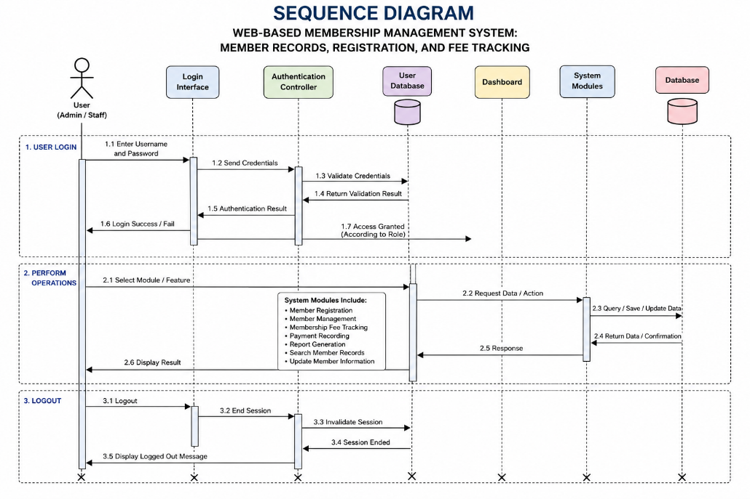

The development of the Web-Based Membership Management System: Member Records, Registration, and Fee Tracking followed the Agile Software Development Methodology, an iterative and incremental approach to software development that emphasizes flexibility, collaboration, continuous improvement, and rapid delivery of functional software. Agile was selected as the software development methodology for this study because it enables developers to respond efficiently to changing user requirements while ensuring that the developed application continuously satisfies the operational needs of the organization.

Unlike traditional software development methodologies, where each phase is completed sequentially, Agile divides the project into smaller development cycles known as iterations or sprints. Each sprint produces a functional component of the application that can be reviewed, tested, and improved before proceeding to the next phase. This iterative approach minimizes development risks, allows early detection of system issues, and provides opportunities for continuous refinement based on user feedback.

The adoption of Agile Software Development Methodology was appropriate for this study because the proposed system required continuous interaction between the researchers and the intended users throughout the development process. Since organizational requirements may evolve during system development, Agile provided the flexibility to accommodate necessary modifications without significantly affecting the project's overall progress. Through regular consultation, evaluation, and testing, the researchers ensured that every module of the developed system accurately reflected the operational requirements of the organization.

The Agile methodology also promotes close collaboration among project stakeholders. Throughout the development process, the researchers communicated regularly with the organization's authorized personnel to validate system requirements, evaluate completed functionalities, and obtain recommendations for system improvement. This collaborative approach helped ensure that the final application addressed the problems identified during the preliminary investigation while maintaining usability, efficiency, reliability, and security.
The development of the Web-Based Membership Management System was carried out through the following Agile phases:

3.2.1 Requirements Gathering
The first phase of the Agile Development Methodology is Requirements Gathering. This phase focuses on collecting the necessary information required for designing and developing the proposed system. It serves as the foundation of the entire software development process because the quality of the developed application largely depends on the accuracy and completeness of the gathered requirements.
During this phase, the researchers will conduct interviews with organizational personnel, observe the existing membership management procedures, and review available documents related to member registration, membership records, and fee collection. These activities will allow the researchers to identify the strengths and weaknesses of the current manual system while determining the organization's specific operational requirements.
The researchers will gather information regarding the existing registration procedures, methods of recording member information, fee collection practices, report preparation, and document management. Particular attention will be given to identifying recurring problems such as duplicate records, delayed processing of membership applications, inaccurate fee monitoring, and difficulties in generating reports. The information collected will provide valuable insights into the processes that require automation.
In addition to identifying existing problems, this phase also aims to determine the expectations of prospective users regarding the proposed web-based application. Functional requirements, including user authentication, member registration, profile management, membership fee tracking, payment recording, report generation, and account management, will be documented. Likewise, non-functional requirements such as security, usability, reliability, performance, maintainability, and compatibility will also be identified to ensure that the proposed system satisfies recognized software quality standards.
At the conclusion of this phase, the researchers will compile and organize all gathered information into a comprehensive Software Requirements Specification (SRS). This document will serve as the primary reference throughout the succeeding stages of system development and will guide the design and implementation of the proposed Membership Management System.

3.2.2 Requirements Analysis
Following the collection of requirements, the researchers will proceed to the Requirements Analysis phase. This phase involves examining, organizing, validating, and prioritizing all gathered information to determine the exact functionalities and technical specifications that the proposed system must provide.
The researchers will carefully analyze the organization's current workflow to identify unnecessary procedures, repetitive tasks, and operational bottlenecks that contribute to inefficiency. Existing manual processes will be evaluated to determine which activities can be automated through the implementation of the proposed web-based system. This analysis will ensure that every module developed directly addresses the identified problems encountered by the organization.
During this phase, the functional requirements of the proposed system will be finalized. These include user authentication, member registration, membership profile management, membership fee recording, contribution history monitoring, report generation, user account administration, and system security. Each requirement will be evaluated to determine its importance, feasibility, and contribution to the overall objectives of the project.
The researchers will also establish the non-functional requirements that define the quality attributes of the proposed application. These include system performance, response time, compatibility with modern web browsers, data security, ease of use, maintainability, scalability, and reliability. These quality requirements will later serve as the basis for evaluating the completed system using the ISO/IEC 25010 Software Quality Model.
The results of the Requirements Analysis phase will guide the preparation of the overall system design, database structure, user interface layout, and software architecture. By carefully validating every requirement before development begins, the researchers can minimize errors, reduce unnecessary revisions, and ensure that the final application effectively supports the operational requirements of the organization.
request, processes the required operation, communicates with the database, and returns the processed information to the user interface.
Whenever information is added, modified, or retrieved, the database updates its records accordingly while preserving data consistency and integrity. Reports generated by the system are produced directly from the centralized database, ensuring that administrators receive accurate and up-to-date information for monitoring and decision-making.

Advantages of the Proposed System Architecture
The adoption of a three-tier client-server architecture provides several advantages for the proposed Membership Management System. These include:
- Centralized Data Management. All membership records and financial transactions are stored in a single database, ensuring consistency and eliminating data redundancy.
- Improved Security. User authentication, role-based authorization, and controlled database access protect confidential organizational information from unauthorized users.
- Scalability. The architecture allows additional system modules and functionalities to be incorporated in future versions without requiring major changes to the overall system structure.
- Maintainability. Since the presentation layer, application logic, and database are separated, future maintenance, debugging, and software updates can be performed more efficiently.
- Performance Efficiency. Processing responsibilities are distributed among different layers, enabling the system to handle multiple user requests while maintaining stable performance.
- Data Integrity. The centralized relational database minimizes duplicate records, preserves relationships among data, and ensures accurate information management.
The implementation of this three-tier client-server architecture provides a stable and efficient foundation for the proposed Web-Based Membership Management System. By integrating the presentation layer, application layer, and database layer into a unified architecture, the proposed system is expected to provide secure, reliable, scalable, and efficient membership management services that support the operational requirements of organizations.

3.2.3 System Planning
After the completion of the requirements analysis, the researchers will proceed to the System Planning phase. This phase establishes the overall direction of the project by determining the scope, objectives, development schedule, required resources, and implementation strategies for the proposed Web-Based Membership Management System: Member Records, Registration, and Fee Tracking. Effective planning serves as the foundation for the successful completion of the project by ensuring that all development activities are properly organized and aligned with the objectives of the study.
During this phase, the researchers will identify the major system modules to be developed based on the functional and non-functional requirements gathered from the organization. These modules include user authentication, member registration, member records management, membership fee tracking, payment monitoring, report generation, and user account administration. Each module will be carefully planned to ensure that it contributes to the overall functionality and objectives of the proposed system.
The researchers will also establish a development schedule that outlines the sequence of activities to be performed throughout the software development life cycle. The schedule will allocate sufficient time for system analysis, interface design, database development, programming, software testing, system evaluation, documentation, and implementation. Proper scheduling enables the researchers to monitor project progress, accomplish development milestones within the allotted timeframe, and minimize delays during implementation.
Resource planning will also be conducted during this stage. The researchers will determine the hardware, software, and development tools required to successfully build the proposed application. Modern web development technologies such as React with TypeScript for the frontend, Node.js and Express.js for server-side development, MySQL as the relational database management system, and Visual Studio Code as the integrated development environment will be utilized to develop a secure, scalable, and efficient web application. These technologies were selected because of their reliability, compatibility, and ability to support the requirements of the proposed information system.
Risk assessment likewise forms an essential component of the planning phase. The researchers will identify possible technical and operational risks that may affect the development of the proposed system, including software compatibility issues, data security concerns, hardware limitations, scheduling conflicts, and unexpected programming challenges. Appropriate contingency measures will be prepared to minimize the impact of these risks and ensure the continuous progress of system development.
Furthermore, communication and collaboration strategies will be established among the researchers, adviser, and prospective users to facilitate continuous monitoring and evaluation throughout the development process. Regular consultations and progress reviews will allow the researchers to verify that the system development remains aligned with the project objectives while providing opportunities for immediate revisions whenever necessary.
At the conclusion of the System Planning phase, the researchers will have a comprehensive development plan that clearly defines the project's objectives, resources, schedule, responsibilities, and implementation strategy. This plan will serve as the primary guide throughout the remaining phases of the Agile Development Methodology and will ensure that the proposed Membership Management System is developed systematically, efficiently, and within the scope of the study.

3.2.4 System Design
The System Design phase focuses on translating the identified requirements into a comprehensive blueprint that serves as the foundation for the development of the proposed Web-Based Membership Management System: Member Records, Registration, and Fee Tracking. During this stage, the researchers will design the overall structure of the system, including its architecture, database, user interface, system modules, process flow, and security mechanisms. A well-planned system design ensures that all components of the application function cohesively and effectively satisfy the operational requirements of the organization.
The researchers will adopt a three-tier client-server architecture, which separates the application into the Presentation Layer, Application Layer, and Database Layer. This architectural approach enhances system maintainability, scalability, security, and performance by separating user interaction, business logic, and data management into independent components. The Presentation Layer will provide users with a responsive and intuitive web interface, the Application Layer will process business logic and enforce system rules, while the Database Layer will securely manage all organizational records and financial transactions.
A relational database will be designed using MySQL to organize and store all information required by the system. The database structure will include interconnected tables for user accounts, member profiles, membership registration records, membership fee payments, transaction history, and generated reports. Relationships between tables will be established using primary and foreign keys to preserve referential integrity and eliminate unnecessary data redundancy. Appropriate constraints and validation rules will also be implemented to maintain data consistency and accuracy throughout the database.
The user interface will be carefully designed to provide a simple, organized, and user-friendly environment for administrators and authorized personnel. Interface layouts will follow accepted usability principles by maintaining consistency in navigation, typography, color schemes, and system controls. Input validation mechanisms, confirmation dialogs, notification messages, and responsive page layouts will be incorporated to improve user interaction while minimizing input errors during data entry and transaction processing.
During this phase, the researchers will also prepare the necessary system models and design documents that describe the operation of the proposed application. These include the Context Diagram, Data Flow Diagrams, Entity Relationship Diagram (ERD), Use Case Diagram, Activity Diagram, Sequence Diagram, Class Diagram, Deployment Diagram, System Architecture Diagram, and Database Schema. These diagrams illustrate the relationships among system components, data flow, user interactions, and database structure, thereby providing a comprehensive representation of the proposed information system before implementation begins.
Security considerations will likewise be integrated into the overall system design. User authentication, role-based authorization, password encryption, session management, and controlled database access will be incorporated to protect confidential organizational information from unauthorized access. Data validation procedures will also be implemented to ensure that only valid and authorized information is stored within the database.
Finally, the System Design phase will establish the technical specifications that will guide the actual development of the proposed application. By carefully planning every component of the system prior to programming, the researchers can reduce development errors, simplify software maintenance, and ensure that the completed Membership Management System meets both the functional requirements of the organization and internationally recognized software quality standards.

3.2.5 System Development
The System Development phase involves the actual construction of the proposed Web-Based Membership Management System: Member Records, Registration, and Fee Tracking based on the requirements gathered, analyzed, and designed during the previous phases. At this stage, the researchers will translate the approved system design into a fully functional web-based application by integrating the selected programming languages, development frameworks, database technologies, and software development tools. The primary objective of this phase is to produce a secure, efficient, responsive, and user-friendly information system that satisfies the operational requirements of the organization.
The development process will follow the Agile principle of iterative and incremental development. Instead of constructing the entire system at once, the researchers will develop the application module by module. Each completed module will undergo preliminary testing and evaluation before proceeding to the next development stage. This iterative approach allows the researchers to identify software defects early, implement improvements immediately, and ensure that each system component functions according to its intended purpose.
The proposed system will be developed using React with TypeScript for the frontend interface. React provides a component-based architecture that enables the creation of reusable user interface components, while TypeScript improves software reliability by introducing static type checking and reducing programming errors during development. The combination of these technologies will provide users with a responsive, organized, and interactive web interface capable of supporting various administrative tasks efficiently.
The server-side application will be developed using Node.js together with the Express.js Framework. Node.js provides a fast and scalable runtime environment capable of handling multiple user requests simultaneously, while Express.js simplifies the development of server-side functionalities through its lightweight architecture. The backend application will be responsible for processing user requests, validating input data, implementing business rules, managing user authentication, and facilitating communication between the client interface and the database.

The proposed system will utilize MySQL as its Relational Database Management System (RDBMS). The database will store all organizational information, including member profiles, registration records, membership fee transactions, user accounts, transaction histories, and generated reports. Proper normalization techniques, database relationships, primary keys, foreign keys, and integrity constraints will be implemented to minimize data redundancy and maintain the consistency of stored information. Database queries will be optimized to improve retrieval speed and ensure efficient processing of user requests.
To ensure software security and protect confidential organizational information, several security mechanisms will be integrated during development. User authentication will require valid login credentials before granting system access. Role-based authorization will restrict system functionalities according to the privileges assigned to administrators and authorized personnel. Passwords will be encrypted before being stored in the database, while input validation and server-side verification will be implemented to minimize the risks associated with unauthorized access, invalid data entry, and common web application vulnerabilities.
Throughout the development process, the researchers will maintain a modular programming structure to improve software maintainability and scalability. Each functional component of the application—including user authentication, member registration, member profile management, membership fee tracking, payment recording, report generation, and user account management—will be developed as independent modules. This modular approach allows future enhancements and additional functionalities to be incorporated with minimal modification to the existing source code.
Version control practices and continuous code refinement will also be observed throughout the development process. Newly implemented features will be reviewed and evaluated to verify their compatibility with existing modules before integration into the main application. Whenever software defects or inconsistencies are identified, corrective modifications will immediately be applied to maintain the stability and reliability of the system.
Furthermore, user interface responsiveness and cross-browser compatibility will be considered during development to ensure that the proposed application performs consistently across different desktop and mobile web browsers. Responsive design principles will be implemented so that users can conveniently access the system using various screen sizes without affecting system functionality or usability.
By following a structured and iterative development process, the researchers aim to produce a reliable web-based application capable of automating membership management activities, improving record accuracy, simplifying membership fee monitoring, and enhancing administrative efficiency. The successful completion of this phase will produce a fully functional system that is ready for comprehensive software testing and evaluation.

3.2.6 System Testing
After completing the development of the proposed system, the researchers will conduct the System Testing phase to verify that every module functions according to the specified requirements. System testing is a critical stage of software development because it ensures that the application performs accurately, reliably, securely, and efficiently before deployment and user evaluation. This phase aims to identify programming errors, validate system functionality, and ensure that the proposed application satisfies both technical and user requirements.
The researchers will perform Black-Box Testing to evaluate the functional behavior of the system without examining its internal source code. This testing technique focuses on verifying whether each system function produces the expected output when provided with valid and invalid input data. Various test cases will be prepared for every module, including user authentication, member registration, profile management, membership fee recording, payment monitoring, report generation, and account administration. The researchers will compare the actual system output with the expected results to determine whether each function operates correctly.
In addition to functional testing, Integration Testing will be conducted to verify that the different modules of the application communicate properly with one another. Since the proposed system consists of several interconnected components, including the frontend interface, application server, and database, integration testing is necessary to ensure that data flows correctly between these layers without causing processing errors or inconsistencies.
The researchers will also perform User Acceptance Testing (UAT) to determine whether the completed application satisfies the needs and expectations of its intended users. Selected administrators and authorized personnel will be given the opportunity to use the developed system and evaluate its functionality, usability, reliability, and overall performance. Feedback gathered during this evaluation will be carefully analyzed and used as the basis for implementing necessary revisions before the final deployment of the application.
Furthermore, the completed system will undergo software quality evaluation using the ISO/IEC 25010 Software Quality Model. The evaluation will assess the acceptability of the proposed application based on the following quality characteristics:
- Functional Suitability
- Performance Efficiency
- Compatibility
- Usability
- Reliability
- Security
- Maintainability
- Portability
The evaluation results will determine whether the proposed system meets internationally recognized software quality standards and is suitable for practical implementation within the organization.
Whenever software defects, inconsistencies, or usability issues are identified during testing, the researchers will immediately implement the necessary corrections and conduct additional testing to verify that the identified problems have been resolved. This process will continue until all critical issues have been addressed and the application demonstrates stable and reliable performance.
The completion of the System Testing phase signifies that the proposed Membership Management System has satisfied the required functional and quality standards and is ready for deployment within the intended organization.

3.2.7 System Deployment
The System Deployment phase marks the completion of the software development process and the beginning of the actual implementation of the proposed Web-Based Membership Management System: Member Records, Registration, and Fee Tracking within the organization. During this phase, the fully tested application will be installed, configured, and prepared for operational use by authorized users. The primary objective of deployment is to ensure that the developed system functions effectively within the intended environment and is readily accessible to administrators and personnel responsible for membership management.
Prior to deployment, the researchers will perform a final verification of all system components to ensure that every module functions according to the approved system specifications. The application will be configured using the appropriate web server, application server, and database server settings to establish stable communication between the frontend, backend, and database. This configuration process ensures that users can securely access the system and perform transactions without interruption.
The deployment process will also involve migrating existing membership records from the manual system into the newly developed database whenever applicable. The researchers will verify the accuracy and completeness of migrated data to ensure that all member information, payment records, and historical transactions are correctly transferred into the new system. Data validation procedures will be conducted to eliminate duplicate records, incomplete information, and inconsistencies that may affect system performance.
To facilitate a smooth transition from the manual process to the computerized system, the researchers will provide user orientation and operational guidance to authorized personnel. Administrators will be introduced to the different system modules, including member registration, profile management, membership fee tracking, payment recording, report generation, and account administration. This orientation will familiarize users with the system's features and enable them to perform their assigned responsibilities efficiently.
Following the installation and user orientation, the researchers will conduct an initial operational evaluation to monitor the performance of the application during actual use. The evaluation will focus on system responsiveness, processing speed, accessibility, security, and overall functionality. Any issues identified during the initial implementation will be documented and addressed immediately to maintain the reliability and stability of the system.
The deployment phase also includes the preparation of technical documentation, user manuals, installation guides, and database backup procedures. These documents provide administrators with sufficient information regarding the operation, maintenance, and management of the application. Proper documentation also supports future system enhancement and simplifies troubleshooting whenever technical issues arise.
By successfully completing the deployment phase, the proposed Membership Management System will become fully operational and capable of supporting the organization's daily membership management activities. The implementation of the system is expected to improve administrative efficiency, enhance record accuracy, simplify fee monitoring, and provide a centralized platform for managing organizational information.

3.2.8 System Maintenance
The final phase of the Agile Development Methodology is System Maintenance. This phase ensures that the proposed Web-Based Membership Management System: Member Records, Registration, and Fee Tracking continues to operate efficiently after deployment. Maintenance activities focus on preserving the reliability, security, performance, and overall functionality of the application while accommodating future organizational requirements and technological advancements.
Following deployment, the researchers will continuously monitor the performance of the system to identify software defects, operational issues, and potential areas for improvement. Regular monitoring enables the early detection of problems that may affect system performance, allowing corrective measures to be implemented before they significantly impact users or organizational operations.
Corrective maintenance will be performed whenever software bugs, programming errors, or system malfunctions are identified. The researchers will investigate the root cause of each issue, implement the necessary corrections, and conduct additional testing to verify that the problem has been completely resolved without affecting other system functionalities.
Adaptive maintenance will also be considered to ensure that the application remains compatible with future software updates, web browsers, operating systems, and database technologies. As technology continues to evolve, modifications may become necessary to maintain system compatibility and ensure uninterrupted operation across different computing environments.
Perfective maintenance focuses on improving the efficiency and usability of the system based on user feedback and operational experience. Suggestions from administrators and authorized personnel may lead to enhancements such as improved navigation, additional reporting features, optimized database performance, refined user interfaces, or the incorporation of new functionalities that further support organizational operations. Continuous improvement allows the system to remain responsive to the changing needs of the organization.
Preventive maintenance will likewise be performed to minimize the possibility of future software failures. Regular database backups, security updates, password management, server monitoring, and performance optimization procedures will be conducted to protect organizational information from data loss, unauthorized access, and other potential security threats. These preventive measures contribute to the long-term stability and dependability of the proposed application.
Documentation updates will also be maintained whenever significant modifications are introduced into the system. Updated technical documentation, user manuals, and maintenance records provide valuable references for future developers, system administrators, and organizational personnel responsible for managing the application.
Through continuous maintenance, the proposed Membership Management System can sustain its operational effectiveness, preserve software quality, and adapt to future organizational requirements. The maintenance phase supports the long-term success of the system by ensuring that it remains secure, reliable, maintainable, and capable of delivering efficient membership management services throughout its operational life cycle.

The Web-Based Membership Management System: Member Records, Registration, and Fee Tracking was designed using a Three-Tier Client-Server Architecture, a widely adopted software architecture for web-based applications. This architectural model separates the system into three independent yet interconnected layers: the Presentation Layer, Application Layer, and Data Layer. The separation of these layers improves the maintainability, scalability, security, and overall performance of the application by assigning specific responsibilities to each component.

The system architecture provides an organized framework for processing user requests, executing business logic, and managing data efficiently. When an authorized user accesses the application through a web browser, the request is transmitted to the application server where it is validated, processed, and communicated to the database server whenever necessary. The processed information is then returned to the user through the web interface. This structured communication ensures efficient processing of transactions while maintaining the integrity and security of organizational data.

The adopted architecture also simplifies future system maintenance and expansion. Since each layer performs a specific function, modifications or updates made to one layer have minimal impact on the other components of the system. This allows future developers to implement enhancements, correct system errors, or introduce additional functionalities without requiring major modifications to the entire application.
The Three-Tier Client-Server Architecture consists of the following components:

Presentation Layer
The Presentation Layer serves as the front-end interface through which users interact with the system. It is responsible for displaying information, receiving user input, validating basic client-side data, and providing navigation to the different modules of the application. This layer was developed using HTML5, CSS3, Bootstrap, and JavaScript to create a responsive, user-friendly, and visually consistent interface.
Authorized users, such as administrators and staff members, can access the system using a standard web browser. Through this interface, users can perform various operations, including logging into the system, registering members, updating member information, recording membership fee payments, viewing reports, and managing user accounts.

The Presentation Layer emphasizes usability and accessibility by providing organized menus, responsive layouts, input validation, and intuitive navigation, allowing users to perform administrative tasks efficiently with minimal training.

Application Layer
The Application Layer functions as the core processing unit of the system. It contains the business logic responsible for interpreting user requests, validating submitted information, enforcing system rules, processing transactions, and communicating with the database.

This layer was developed using PHP, which serves as the server-side scripting language responsible for executing the application's functional processes. Whenever users submit information through the interface, the Application Layer verifies the accuracy and completeness of the data before storing or retrieving records from the database.

Major responsibilities of this layer include:
- User authentication and login verification;
- Role-based access control for administrators and staff;
- Member registration processing;
- Member record management;
- Membership fee management;
- Payment transaction processing;
- Report generation;
- Search and filtering of records;
- Session management; and
- Input validation and error handling.
By centralizing the business logic within the Application Layer, the system maintains consistency, prevents unauthorized operations, and ensures that all transactions follow the organization's established procedures.

Data Layer
The Data Layer serves as the centralized repository of all information managed by the application. It utilizes MySQL, a Relational Database Management System (RDBMS), to securely store, organize, retrieve, and update organizational records.

The database contains interconnected tables that manage user accounts, member information, membership categories, membership fee records, payment transactions, and other system-related data. Relationships among these tables are established using primary keys and foreign keys, ensuring data consistency, minimizing redundancy, and preserving referential integrity.

Whenever information is added, modified, or retrieved, the Application Layer communicates directly with the database while ensuring that only validated and authorized requests are executed. This controlled communication protects the database from unauthorized access and maintains the confidentiality and integrity of organizational information.

In addition, regular database backup procedures and maintenance activities are recommended to safeguard records against accidental loss or system failure. These practices contribute to the long-term reliability and sustainability of the developed application.

Overall System Architecture

The Three-Tier Client-Server Architecture adopted in this study provides a secure, efficient, and scalable framework for the Web-Based Membership Management System. By separating the presentation, application, and data layers, the system promotes better organization of software components, simplifies maintenance, enhances security, and improves overall performance.

This architectural design supports the system's major functionalities, including user authentication, member registration, member record management, membership fee tracking, payment recording, and report generation. It also provides a flexible foundation for future enhancements, allowing additional features and modules to be incorporated without significantly affecting the existing structure of the application.

3.3 SYSTEM ARCHITECTURE

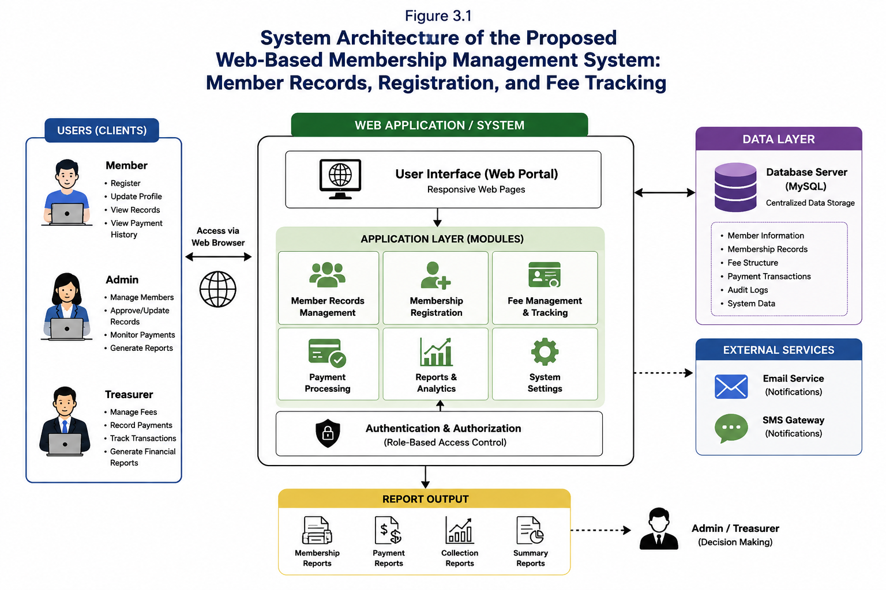

The system architecture of the Web-Based Membership Management System: Member Records, Registration, and Fee Tracking illustrates the overall structure of the developed application and demonstrates how its major components interact to perform the required system functions. It serves as the blueprint of the system by identifying the relationship among the users, the web application, the application server, and the database server. A well-designed system architecture ensures that data is processed efficiently, securely, and accurately while supporting the operational requirements of the organization.

The developed application follows a three-tier architecture consisting of the Presentation Layer, Application Layer, and Data Layer. This architectural model separates the user interface, application logic, and database management into independent layers, making the system more organized, maintainable, scalable, and easier to update in the future. The separation of responsibilities also improves system performance by allowing each layer to perform its designated functions without interfering with other components.

Presentation Layer
The Presentation Layer serves as the user interface of the system. It is the component through which authorized users interact with the application using a web browser. The interface provides access to the different system modules such as user authentication, member registration, member record management, membership fee tracking, payment recording, and report generation.

The graphical user interface was designed to be simple, responsive, and user-friendly to ensure that administrators and staff members can perform their tasks efficiently. Input forms, tables, buttons, menus, and navigation panels were carefully organized to provide an intuitive user experience while minimizing user errors during data entry.
Application Layer
The Application Layer contains the business logic of the developed system. It processes user requests, validates input data, executes system operations, and coordinates communication between the presentation layer and the database.
Whenever an authorized user performs a transaction, such as registering a new member or recording a membership fee payment, the application layer verifies the submitted information, applies the necessary business rules, and determines the appropriate response. If the information is valid, the application communicates with the database to store or retrieve records. Otherwise, appropriate validation messages are displayed to the user.
This layer was developed using PHP as the server-side scripting language, enabling dynamic processing of requests and efficient communication with the MySQL database.
Data Layer
The Data Layer is responsible for storing, organizing, retrieving, and managing all organizational information used by the application. It consists of a MySQL relational database that securely stores user accounts, member information, membership categories, membership fee records, payment transactions, and generated reports.
The database was designed using normalization techniques to reduce data redundancy, improve storage efficiency, and maintain referential integrity among related tables. Primary keys and foreign keys were implemented to establish relationships between entities and ensure the consistency and accuracy of stored information.
All database operations, including data insertion, updating, searching, and report generation, are performed through structured SQL queries executed by the application layer.

System Workflow
The operation of the system begins when an authorized user accesses the application through a web browser and enters valid login credentials. The request is transmitted to the application layer, where the login information is authenticated using records stored in the MySQL database.
After successful authentication, the user is granted access to the system dashboard according to the assigned access level. From the dashboard, the user may register members, update member information, record membership fee payments, search records, monitor payment history, and generate reports.

Every transaction performed by the user is processed by the application layer before being stored in or retrieved from the database. The processed information is then returned to the presentation layer and displayed to the user through the web interface. This continuous communication among the three architectural layers ensures accurate processing of organizational information while maintaining security, reliability, and efficient system performance.

Advantages of the System Architecture
The implementation of the three-tier architecture provides several advantages to the developed system. It improves maintainability by separating the user interface, business logic, and database into independent components. It enhances system security by limiting direct access to the database and ensuring that all transactions pass through the application layer for validation.

Furthermore, the architecture promotes scalability, allowing additional modules and functionalities to be incorporated into the system without significantly affecting existing components. It also improves system performance by organizing application processes into specialized layers that efficiently handle user requests and database operations.

The overall architecture enables the Web-Based Membership Management System to deliver reliable, secure, and efficient services while supporting the organization's daily membership management activities.

3.4 TOOLS AND TECHNOLOGIES USED
The development of the Web-Based Membership Management System: Member Records, Registration, and Fee Tracking required the use of various software development tools, programming languages, frameworks, and database technologies. These tools were carefully selected based on their reliability, compatibility, efficiency, ease of use, and suitability for developing database-driven web applications. The integration of these technologies enabled the researchers to design, develop, test, and implement a secure, responsive, and user-friendly information system that effectively meets the requirements of the organization.
Table 3.1 presents the software tools and technologies utilized throughout the development of the proposed system.

Table 3.1 Tools and Technologies Used

Tool / Technology | Purpose
PHP | Server-side scripting language used to process system functions and business logic
HTML5 | Provides the structural framework of the web pages
CSS3 | Styles and enhances the visual appearance of the user interface
Bootstrap 5 | Develops a responsive and mobile-friendly user interface
JavaScript | Implements client-side interactivity and form validation
MySQL | Relational Database Management System (RDBMS) used to store system data
XAMPP | Local server environment used for application development and testing
Apache Web Server | Hosts the web application within the XAMPP environment
phpMyAdmin | Database administration tool for managing MySQL databases
Visual Studio Code | Source code editor used during software development
Google Chrome / Microsoft Edge | Web browsers used for system testing and execution

PHP
PHP (Hypertext Preprocessor) served as the primary server-side programming language used in the development of the application. It was responsible for processing user requests, executing business logic, communicating with the database, validating user input, and generating dynamic web pages.
Within the developed system, PHP handled critical operations such as user authentication, member registration, member record management, membership fee processing, payment recording, report generation, and session management. Its seamless integration with MySQL made it a suitable choice for developing a secure and efficient database-driven web application.

HTML5
HTML5 was used to create the structural framework of every web page within the application. It provided the layout for forms, navigation menus, tables, buttons, dashboards, and other interface components necessary for system operation.
By utilizing semantic HTML elements, the researchers developed an organized and accessible interface that allows administrators and staff members to navigate the application efficiently.

CSS3
CSS3 was utilized to improve the visual appearance and overall usability of the system. It controlled the formatting, colors, typography, spacing, and positioning of interface elements, resulting in a clean and professional design.

The use of CSS3 also ensured visual consistency across different pages of the application while enhancing readability and user experience.

Bootstrap 5
Bootstrap 5 served as the front-end framework for developing a responsive and device-independent user interface. Its built-in components and responsive grid system enabled the researchers to create pages that automatically adjust to different screen sizes without requiring extensive custom styling.

Bootstrap also improved the consistency of interface elements such as navigation bars, buttons, tables, forms, cards, and modal windows, providing users with an intuitive and professional interface.

JavaScript
JavaScript was utilized to implement interactive features within the application. It enhanced the responsiveness of the system by performing client-side validation, displaying confirmation messages, updating interface components dynamically, and improving overall user interaction.
Client-side validation minimized unnecessary server requests by detecting invalid input before form submission, thereby improving system performance and user experience.

MySQL
MySQL served as the Relational Database Management System (RDBMS) responsible for storing and managing all organizational data. It maintained information related to user accounts, member records, membership categories, membership fees, payment transactions, and generated reports.

The use of MySQL ensured efficient storage, retrieval, updating, and management of data while preserving data integrity through the implementation of relational constraints, primary keys, and foreign keys.

XAMPP
XAMPP was used as the local development environment during system implementation. It integrated Apache Web Server, PHP, MySQL, and phpMyAdmin into a single platform, enabling the researchers to develop and test the application locally before deployment.

The XAMPP environment simplified application configuration and provided a stable platform for debugging and testing various system functionalities.

Apache Web Server
The Apache Web Server functioned as the web server responsible for hosting the developed application within the XAMPP environment. It processed incoming client requests and delivered the appropriate web pages to users through their web browsers.
Apache enabled smooth communication between the presentation layer and the application layer, allowing users to access system features efficiently.

phpMyAdmin
phpMyAdmin was utilized as the graphical database administration tool for MySQL. It enabled the researchers to create database tables, define relationships, manage records, execute SQL queries, and monitor the overall database structure through a web-based interface.

Its graphical environment simplified database administration and facilitated efficient management of organizational data during system development.

Visual Studio Code
Visual Studio Code served as the primary Integrated Development Environment (IDE) used throughout the development process. It provided advanced features such as syntax highlighting, intelligent code completion, debugging support, extension integration, and version control compatibility.

These features improved coding efficiency, reduced programming errors, and enhanced the overall software development process.

Web Browsers
Google Chrome and Microsoft Edge were used to test and evaluate the developed application. These browsers allowed the researchers to verify interface responsiveness, system functionality, compatibility, and performance under different operating conditions.
Browser-based testing ensured that the developed application consistently displayed pages correctly and executed system functions accurately across supported platforms.
The combination of these tools and technologies provided a stable, secure, and efficient development environment for the Web-Based Membership Management System. Their integration enabled the researchers to develop a responsive, database-driven application capable of managing membership registration, member records, membership fee tracking, and report generation while maintaining high standards of performance, security, and usability.

3.5 DATA GATHERING TECHNIQUES
The success of the Web-Based Membership Management System: Member Records, Registration, and Fee Tracking largely depended on the accuracy and completeness of the information gathered during the initial stages of the study. To ensure that the developed system effectively addressed the organization's operational requirements, the researchers employed several data gathering techniques to obtain relevant and reliable information regarding the existing membership management process.
The data gathering process enabled the researchers to understand the organization's workflow, identify the challenges encountered in the manual system, determine the users' requirements, and collect the necessary information that served as the basis for the design and development of the proposed web-based application. The following data gathering techniques were utilized throughout the conduct of the study.
Interview

The interview method was one of the primary techniques used in gathering information for the study. The researchers conducted informal and structured interviews with the organization's authorized personnel, including administrators and staff members responsible for managing membership records and membership fee transactions.
During the interviews, the researchers gathered information regarding the existing membership registration procedures, record management practices, fee collection processes, report preparation, and overall administrative workflow. The participants were also asked to identify the difficulties they commonly encountered while using the manual system, including problems related to data recording, retrieval of member information, payment monitoring, and report generation.

The information obtained through the interviews allowed the researchers to determine the functional requirements of the proposed system and identify opportunities for process improvement through automation.

Observation
Observation was conducted to obtain a direct understanding of how the organization's membership management activities were performed. The researchers carefully observed the daily administrative procedures related to member registration, maintenance of member records, monitoring of membership fee payments, and preparation of reports.
Through direct observation, the researchers identified the sequence of activities performed by authorized personnel, the documents utilized during transactions, the flow of information between users, and the common problems encountered during manual operations. This technique enabled the researchers to verify the information obtained during the interviews and gain a better understanding of the organization's actual operational environment.
The observations also helped identify repetitive tasks that could be automated by the proposed system, thereby improving efficiency and reducing administrative workload.

Document Analysis
Document analysis was conducted to examine the records, forms, and documents currently used by the organization in managing its membership information. These documents included membership registration forms, member information records, payment records, fee collection reports, and other administrative documents relevant to the organization's operations.

The researchers carefully analyzed the contents and structure of these documents to determine the specific data elements required by the proposed system. This process also helped identify unnecessary duplication of information, inconsistencies in record keeping, and opportunities for improving data organization through database normalization.
The findings obtained through document analysis served as the basis for designing the database structure, input forms, and report generation modules of the developed application.

Requirements Validation
After gathering information through interviews, observation, and document analysis, the researchers conducted a validation of the collected requirements with the organization's authorized personnel. This activity ensured that the identified functional and non-functional requirements accurately reflected the organization's operational needs and expectations.

The researchers presented the proposed system features, workflow, and major functionalities to the intended users for confirmation and clarification. Feedback and suggestions provided during this stage were carefully evaluated and incorporated into the system requirements whenever appropriate.
Requirements validation minimized misunderstandings during system development and ensured that the final application effectively addressed the problems identified during the preliminary investigation.

Data Analysis
The information collected through the different data gathering techniques was carefully organized, reviewed, and analyzed to determine the specific requirements of the proposed Web-Based Membership Management System. The researchers categorized the gathered information into functional requirements, non-functional requirements, database requirements, security requirements, and reporting requirements.
The analyzed data served as the foundation for the preparation of the system design, database structure, software architecture, user interface, and application modules. Furthermore, the findings obtained during this phase guided the researchers throughout the software development process, ensuring that every component of the developed application addressed the actual needs of the organization.

Overall, the combination of interviews, observation, document analysis, requirements validation, and data analysis enabled the researchers to gather comprehensive and reliable information necessary for the successful development of the Web-Based Membership Management System. These data gathering techniques ensured that the developed application was based on actual organizational requirements and effectively supported the automation of membership registration, member record management, membership fee tracking, and report generation.

3.6 TESTING PROCEDURES
Testing is an essential phase in the development of the Web-Based Membership Management System: Member Records, Registration, and Fee Tracking. It was conducted to ensure that the developed application functions according to the specified requirements and performs accurately, efficiently, and reliably under normal operating conditions. Through systematic testing, the researchers verified that each module of the system operated correctly, interacted properly with other components, and met the operational needs of the organization.

The primary objective of system testing was to identify programming errors, validate system functionalities, ensure data accuracy, and evaluate the overall quality of the developed application before deployment. Throughout the testing process, the researchers conducted various testing procedures to determine whether the system successfully fulfilled its intended functions while maintaining acceptable levels of performance, security, and usability.

To comprehensively evaluate the developed application, several software testing methods were employed during different stages of system development. These included Unit Testing, Integration Testing, System Testing, and User Acceptance Testing (UAT). Each testing procedure focused on a specific aspect of the application to ensure that all modules functioned properly both individually and collectively.

Unit Testing
Unit Testing was performed to evaluate each individual module of the application independently. During this phase, the researchers tested every function developed for the system to determine whether it produced the expected output based on the specified input.
The individual modules tested included the User Authentication Module, Member Registration Module, Member Records Management Module, Membership Category

Management Module, Membership Fee Management Module, Payment Recording Module, Report Generation Module, and User Account Management Module.

Each module was examined for programming errors, incorrect calculations, missing input validation, and unexpected system behavior. Whenever issues were identified, the researchers immediately corrected the errors before integrating the module with the other components of the system. Conducting Unit Testing at an early stage minimized software defects and improved the overall quality and reliability of the application.
Integration Testing

After successfully completing Unit Testing, the researchers conducted Integration Testing to verify that all system modules communicated correctly with one another. This phase ensured that information entered into one module was accurately transferred and reflected in other related modules.

The researchers carefully evaluated the interaction between the user interface, application logic, and MySQL database. Integrated processes such as member registration, updating member records, recording membership fee payments, generating reports, and user authentication were tested to ensure that they functioned properly as a complete system.
Integration Testing also confirmed that the relationships among database tables were correctly implemented and that information was consistently processed throughout the application. This procedure minimized data inconsistencies and ensured the integrity of all transactions stored in the database.

System Testing
System Testing was conducted after integrating all software modules into a complete and fully functional application. During this phase, the researchers evaluated the overall performance of the Web-Based Membership Management System to determine whether it satisfied all identified functional and non-functional requirements.

Various test scenarios were performed using both valid and invalid data to evaluate the system's ability to process information accurately and respond appropriately to user actions. The researchers assessed the application's response time, user interface functionality, database connectivity, report generation, membership fee tracking, search functions, data validation, and security features.

The results of System Testing demonstrated that the developed application successfully performed all major system functions while maintaining accurate processing of membership information and payment records. The application also exhibited stable performance throughout the testing process.

User Acceptance Testing (UAT)
Following the completion of technical testing procedures, the developed application underwent User Acceptance Testing (UAT). This phase involved selected representatives from the organization who served as actual users of the system. The purpose of User Acceptance Testing was to determine whether the application met the operational requirements and expectations of its intended users.

Participants were requested to perform common administrative tasks such as logging into the system, registering new members, updating member information, recording membership fee payments, searching for member records, and generating reports. Throughout the evaluation, the participants observed the ease of navigation, functionality, efficiency, reliability, and overall usability of the application.

The researchers documented all comments, observations, and recommendations provided by the participants. Minor improvements identified during User Acceptance Testing were incorporated into the final version of the system before deployment. The overall evaluation indicated that the developed application effectively satisfied the organization's operational requirements.

Error Detection and Bug Fixing
Throughout every stage of testing, the researchers continuously monitored the application for programming errors, logical inconsistencies, database issues, and user interface problems. Whenever defects were identified, corrective measures were immediately implemented before repeating the corresponding testing procedures.

The debugging process included correcting syntax errors, improving input validation, optimizing database queries, refining interface components, and enhancing system performance. Continuous debugging contributed significantly to improving the reliability, stability, efficiency, and overall quality of the developed application.

Overall Testing Outcome
The comprehensive testing procedures demonstrated that the Web-Based Membership Management System: Member Records, Registration, and Fee Tracking successfully achieved its intended objectives. All major modules functioned according to the identified system requirements and operated efficiently within the intended development environment.

The testing results confirmed that the developed application provides accurate member registration, reliable member record management, efficient membership fee tracking, secure user authentication, and comprehensive report generation. Furthermore, the evaluation verified that the application maintains data integrity, security, usability, and operational efficiency while supporting.

the organization's daily administrative activities.
Based on the successful completion of all testing procedures, the researchers concluded that the Web-Based Membership Management System is ready for deployment and implementation. The developed application provides a reliable, secure, and sustainable solution for improving the organization's membership management processes through the use of modern web-based technologies

SUPPORTING DIAGRAMS

ENTITY RELATIONSHIP DIAGRAM (ERD)

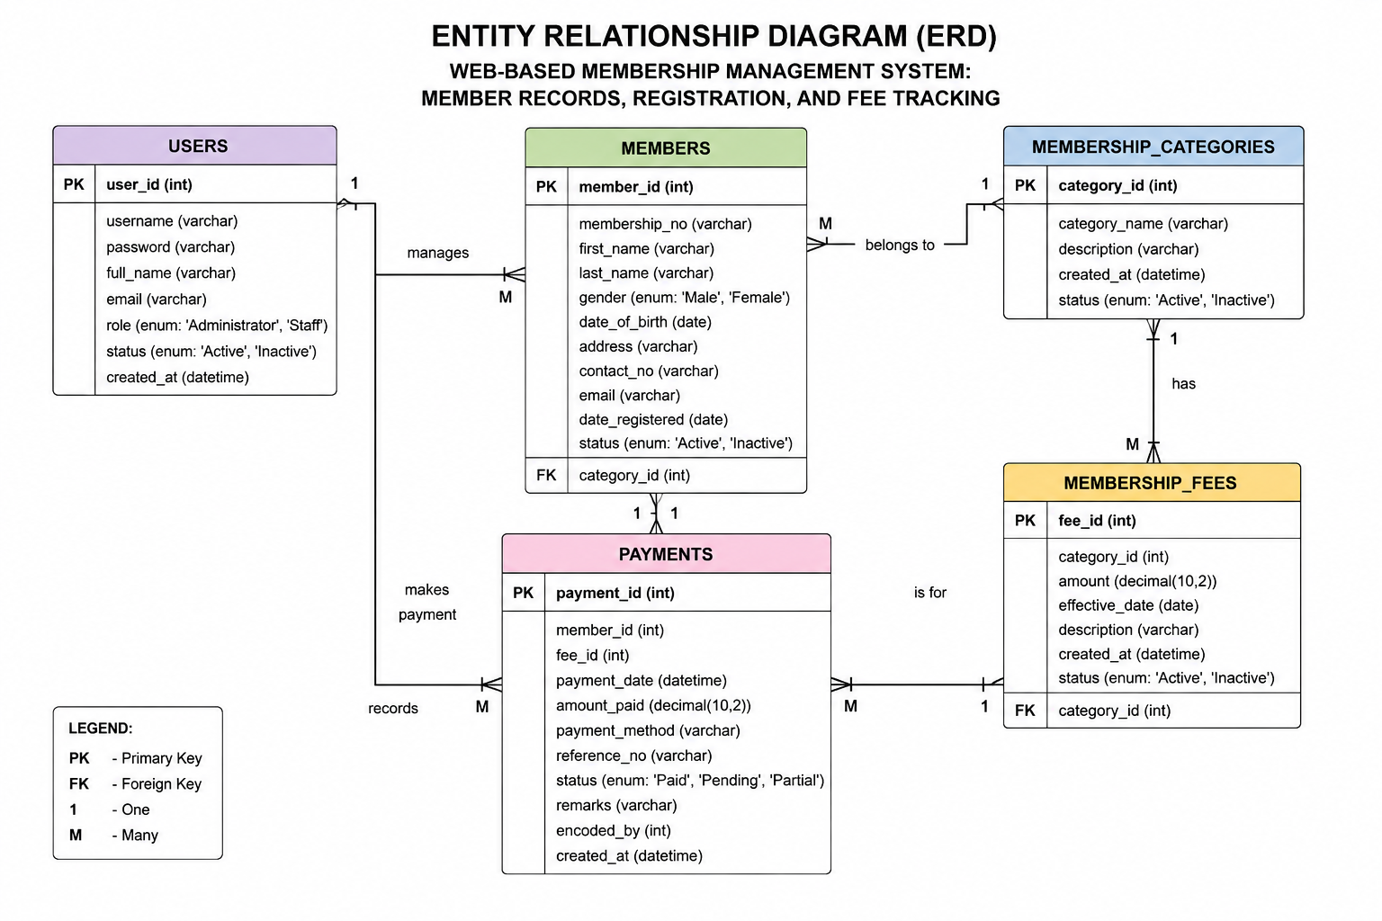

The Entity Relationship Diagram (ERD) illustrates the logical structure of the database used in the Web-Based Membership Management System: Member Records, Registration, and Fee Tracking. It serves as a blueprint for the database by identifying the major entities, their corresponding attributes, and the relationships established among them. The ERD ensures that data is organized efficiently while maintaining data integrity, minimizing redundancy, and supporting accurate information retrieval.
The database was designed using the relational database model implemented through MySQL. Each entity represents a specific collection of related information required for the operation of the system. Relationships between entities are established through the use of primary keys and foreign keys, allowing the application to maintain consistency and integrity across all stored records.

The Entity Relationship Diagram was developed based on the system requirements identified during the requirements gathering and analysis phases. It supports the major functionalities of the developed application, including user authentication, member registration, member record management, membership category management, membership fee tracking, payment recording, and report generation.

The major entities included in the database are the following:

Users
The Users entity stores the account information of all authorized individuals who are permitted to access the system. It contains login credentials, user profiles, account status, and assigned access roles such as Administrator and Staff. This entity is responsible for implementing user authentication and access control throughout the application.
Members

The Members entity contains the personal and membership information of all registered members. It stores records such as the member's name, address, contact information, date of registration, membership status, and assigned membership category. This entity serves as the primary repository of member information within the system.

Membership Categories
The Membership Categories entity stores the different classifications of membership recognized by the organization. Each registered member is assigned to a specific category based on the organization's membership policies. Separating membership categories into a dedicated table minimizes data redundancy and simplifies category management.

Membership Fees
The Membership Fees entity stores the fee structure associated with each membership category. It records the amount required for membership payments, the effective date of the fee, and additional descriptions when necessary. This entity enables administrators to manage membership fees without modifying individual member records.

Payments
The Payments entity records every membership fee transaction made by registered members. It contains information such as the payment amount, payment date, payment status, remarks, and references to both the member and the corresponding membership fee. This entity enables accurate monitoring of payment history and supports financial reporting.

Relationships Among Entities
The relationships established among these entities enable the Web-Based Membership Management System to process transactions efficiently while maintaining database consistency. Each member belongs to one membership category, each membership category may have one or more associated membership fee records, and each payment transaction is linked to a specific member and membership fee. Likewise, authorized users are responsible for managing records and performing administrative functions within the application.

The Entity Relationship Diagram provides a clear representation of how organizational data is stored, related, and managed within the database. It serves as an essential guide during database implementation and ensures that the developed application supports accurate data processing, efficient record management, and reliable report generation.

Figure 3.1 illustrates the Entity Relationship Diagram of the proposed Web-Based Membershp Management System

DATA FLOW DIAGRAM (use case) LEVEL 0

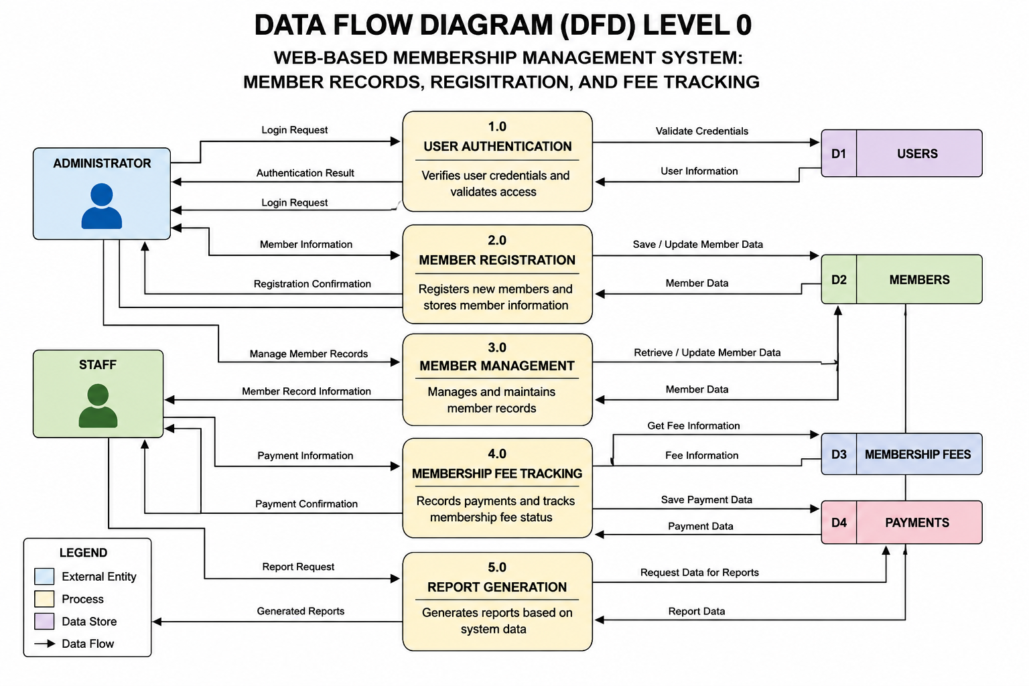

The Data Flow Diagram (DFD) Level 0 presents a high-level view of the major processes and the movement of data within the Web-Based Membership Management System: Member Records, Registration, and Fee Tracking. It illustrates how information flows between the external entities, the main system processes, and the database while demonstrating how data is received, processed, stored, and retrieved during the operation of the system.

The DFD Level 0 serves as a graphical representation of the overall functionality of the proposed system. It provides a clear understanding of the interactions between authorized users and the application without presenting the detailed internal processing performed by each module. Through this model, the researchers were able to visualize the major activities performed by the system and ensure that every functional requirement identified during the requirements gathering phase was properly addressed.

The primary external entities involved in the system are the Administrator and the Staff. These authorized users interact with the application to perform various membership management activities such as user authentication, member registration, updating member records, recording membership fee payments, and generating reports. Both users access the system through the web interface, while their requests are processed according to their assigned access privileges.

The system is composed of five major processes that perform the core operations of the application. The first process, User Authentication, verifies the login credentials of authorized users before granting access to the system. This process ensures that only registered administrators and staff members can access the application's features, thereby protecting confidential organizational information.

The second process, Member Registration, manages the registration of new members by collecting and validating personal information before storing it in the database. This process also allows authorized users to update or modify existing member records whenever necessary.

The third process, Member Management, enables administrators and staff members to organize, search, edit, and maintain member information stored in the system. It ensures that member records remain accurate, complete, and up-to-date while supporting efficient retrieval of information.

The fourth process, Membership Fee Tracking, records membership fee transactions and maintains payment histories for each registered member. It monitors payment status, updates transaction records, and provides accurate information regarding outstanding and completed membership fee payments.

The fifth process, Report Generation, retrieves information from the database and produces organized reports related to registered members, membership fee collections, payment history, and other administrative records. These reports assist administrators in monitoring organizational activities and support informed decision-making.

To support these processes, the system utilizes several data stores that serve as repositories for organizational information. The Users Data Store contains account information for administrators and staff members. The Members Data Store stores all member records and registration details. The Membership Fees Data Store maintains information regarding membership fee structures, while the Payments Data Store stores all payment transactions and payment histories.

The interaction among the external entities, system processes, and data stores enables the application to perform membership management activities efficiently while maintaining data integrity and security. Every transaction performed by authorized users is processed through the appropriate system module and recorded within the corresponding database tables, ensuring that all information remains accurate, organized, and readily available whenever needed.

Figure 3.2 illustrates the Data Flow Diagram (DFD) Level 0 of the proposed Web-Based Membership Management System: Member Records, Registration, and Fee Tracking.

USE CASE DIAGRAM

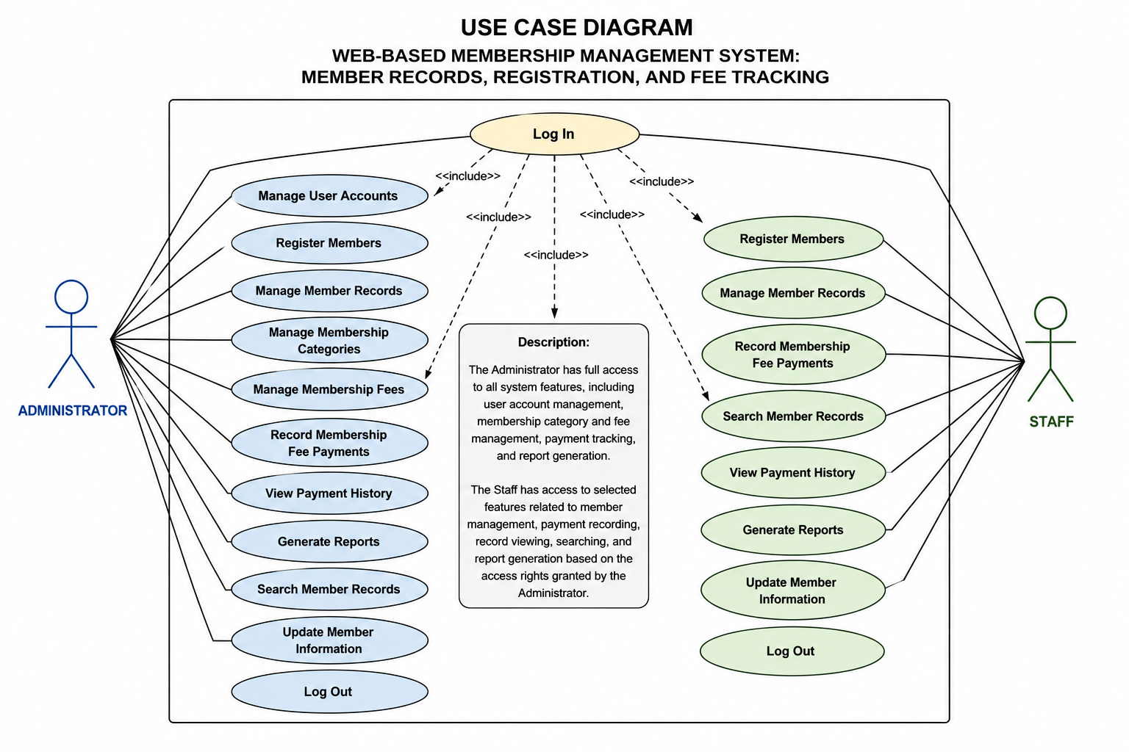

The Use Case Diagram illustrates the interactions between the users and the major functions of the Web-Based Membership Management System: Member Records, Registration, and Fee Tracking. It identifies the different actors who interact with the system and the specific functions that they are authorized to perform. The diagram provides a clear representation of the system's functional requirements by showing how users communicate with the application to accomplish various organizational tasks.

The primary purpose of the Use Case Diagram is to describe the services provided by the system from the perspective of its users. It defines the boundaries of the application, identifies the responsibilities assigned to each user, and demonstrates the relationship between users and the different system modules. This model served as one of the primary references during the design and development of the proposed application.

The developed system has two primary actors: the Administrator and the Staff. Both actors interact with the system through a secure login process before gaining access to the application's functionalities. While both users share several common functions, the Administrator possesses additional privileges related to overall system administration and user account management.
Administrator

The Administrator serves as the primary user of the system and possesses full access to all modules and administrative functions. The Administrator is responsible for managing user accounts, registering new members, maintaining member records, managing membership categories, updating membership fee information, recording payment transactions, monitoring membership fee status, generating reports, and maintaining the overall operation of the system.

The Administrator can perform the following use cases:
• Log In
• Manage User Accounts
• Register Members
• Manage Member Records
• Manage Membership Categories
• Manage Membership Fees
• Record Membership Fee Payments
• View Payment History
• Generate Reports
• Search Member Records
• Update Member Information
• Log Out
Staff
The Staff assists the Administrator in performing the daily membership management operations. Although Staff members have access to several operational modules, their privileges are limited based on the access rights assigned by the Administrator.

The Staff is authorized to perform the following use cases:
• Log In
• Register Members
• Manage Member Records
• Record Membership Fee Payments
• Search Member Records
• View Payment History
• Generate Reports
• Update Member Information
• Log Out

Relationship Between Actors and Use Cases
The Use Case Diagram demonstrates that both the Administrator and Staff interact directly with the Web-Based Membership Management System to perform authorized tasks. Every transaction begins with user authentication through the login process, ensuring that only authorized users can access the application's resources.

After successful authentication, users are granted access to the modules corresponding to their assigned roles. Administrators possess complete administrative control over the system, while Staff members are provided with operational access necessary for performing membership registration, payment recording, and record management. This role-based access control strengthens system security while ensuring that organizational information is managed only by authorized personnel.

The use cases identified in the diagram collectively represent the major functionalities of the developed application and demonstrate how the system supports efficient membership registration, member record management, membership fee tracking, payment monitoring, and report generation.

ACTIVITY DIAGRAM

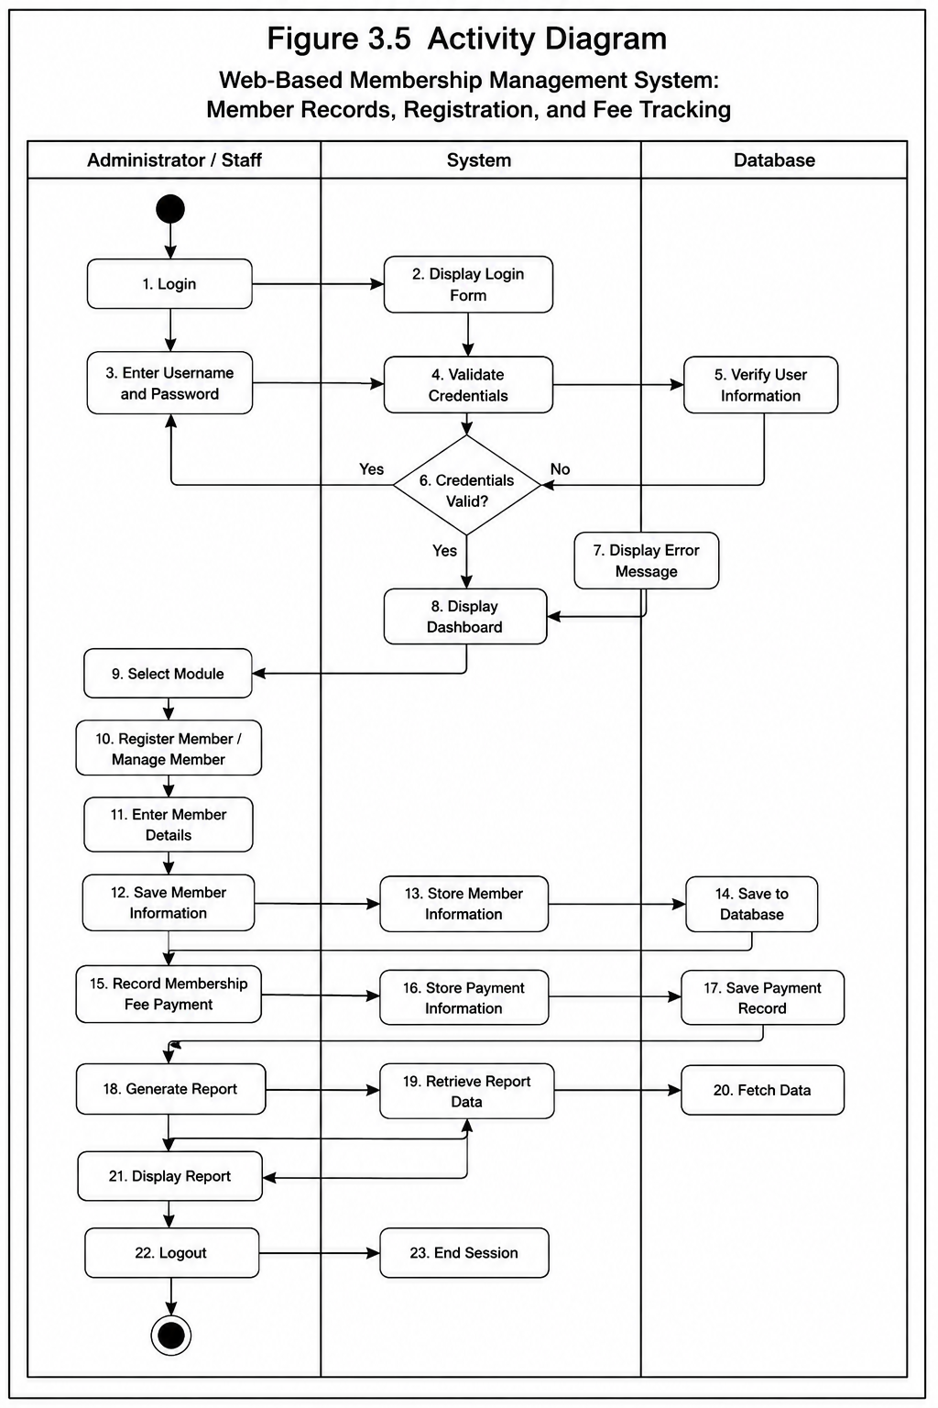

The Activity Diagram presents the sequence of activities and workflow processes involved in the operation of the proposed Web-Based Membership Management System: Member Records, Registration, and Fee Tracking. It provides a visual representation of how users interact with the system and how processes are executed from initiation to completion.
The workflow begins when an authorized user accesses the system and provides login credentials for authentication. The system validates the submitted information before granting access to available functionalities. Once authenticated, users may perform activities such as registering new members, updating member information, managing membership records, recording payments, monitoring fee status, and generating reports.
The diagram also illustrates decision points within the workflow, such as validating user credentials and verifying required information before processing transactions. These conditions ensure that only accurate and complete data are stored within the system database.
The Activity Diagram provides a structured view of the system processes and demonstrates the logical flow of operations. It assists developers and stakeholders in understanding the behavior of the system and ensures that the implemented functionalities align with the identified requirements of the organization.

SEQUENCE DIAGRAM
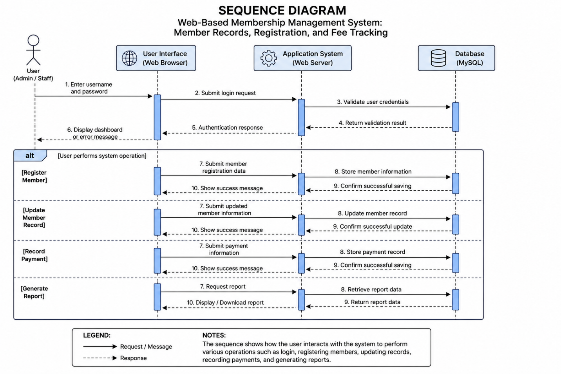

The Sequence Diagram illustrates the chronological interaction between users, system components, and database elements during the execution of specific system functions in the proposed Web-Based Membership Management System: Member Records, Registration, and Fee Tracking. It demonstrates how messages and requests are exchanged among different components to complete a particular operation.
The sequence begins when the user initiates a request through the system interface, such as logging in, registering a member, updating records, recording payments, or generating reports. The application processes the request, communicates with the database to retrieve or store necessary information, and returns the appropriate response to the user.
The diagram highlights the interaction between the User Interface, Application System, and Database, showing how each component contributes to the successful execution of system operations. It provides a detailed representation of system behavior and ensures that the communication flow between components is properly structured.
The Sequence Diagram serves as a guide for system development by describing the order of interactions among system components and ensuring that each function operates according to the intended design.

DEPLOYMENT DIAGRAM

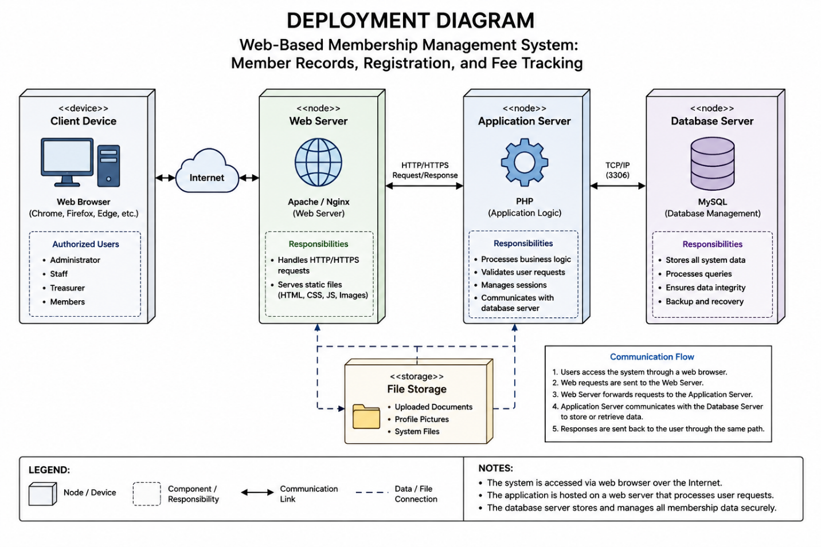

The Deployment Diagram illustrates the physical architecture and implementation environment of the proposed Web-Based Membership Management System: Member Records, Registration, and Fee Tracking. It presents the hardware and software components required for the deployment and operation of the developed system.
The diagram consists of the major nodes involved in system deployment, including the Client Device, Web Server, Application Server, and Database Server. The client devices represent the computers or devices used by authorized personnel to access the system. The web server handles user requests and provides access to the web-based application, while the application server manages system processes and business logic. The database server is responsible for storing, retrieving, and maintaining membership information, payment records, and user account details.
The connections between these components demonstrate the communication flow required for system operation. The Deployment Diagram provides an overview of how the proposed system will be implemented within the organization's computing environment and ensures that the required hardware and software resources are properly identified.

Overall System Interaction

The Use Case Diagram provides an overall view of how the Administrator and Staff interact with the Web-Based Membership Management System. The Administrator manages and oversees system-related activities, while Staff members perform membership-related operations such as registering members, managing member information, recording payments, monitoring membership fees, and generating reports. The diagram presents these interactions in a simple and organized manner, allowing the researchers, developers, and intended users to understand the relationship between the system's users and its major functionalities.

Significance of the Use Case Diagram

The Use Case Diagram is significant because it identifies the actors and functions involved in the Web-Based Membership Management System: Member Records, Registration, and Fee Tracking. It defines the roles of the Administrator and Staff and shows the specific system functions that each authorized user can perform. These functions include user authentication, member registration, member record management, membership fee tracking, payment recording, and report generation. The diagram helps establish clear user responsibilities and access requirements, making it useful as a guide during system development and implementation.

